**CS 3331 Advance Object-Oriented Programming**

**Spring 2020**

**Lab Report #3**

Author: Nichole Maldonado

Due: February 13, 2020

Professor: Dr. Oscar Mondragon

TA: Alireza Nouri

**High-Level Approach**

The main problem of Lab3 was to read a file with chess piece attributes, create the chess pieces, and determine if they can move to a new position selected by the user. One change from this lab was that all the pieces must start in their initial board positions. In order to solve the problem, the first algorithmic step is to get the file path from the user. After doing so, the file needs to be read. The file is read line by line and each line is parsed. The lines are parsed to collect the piece name, color, x position, and y position. My program checks to ensure that the piece name ends with the x position and y position. Additionally, the color is checked to ensure that it is either black or white. After collecting the necessary fields, the piece creation begins. Based on the piece name, the corresponding create piece method is called. In this method, the x and y positions are checked to ensure they are within the board’s bounds. If the piece’s x and y position are not valid starting positions, then the piece is not created. If the position is valid, then the piece is created and added to an array. For the chess pieces, there are six derived classes in total which include Pawn, Rook, Queen, King, Bishop, and Knight. See the class diagrams below to understand the relationships between these classes. (It is important to note that at a lower level of abstraction two classes, FileReader and PieceCreator, are used to read the file and create the pieces). Since the number of pieces on a line is unknown, a dynamic array, or array list, is used instead. After reading the entire file and populating the array with ChessPiece derived class objects, the new x and y positions are collected from the user. These new positions are checked to ensure that they are within the chess board’s bound. Then the entire array list is iterated. For each object the corresponding validMove method is called which determines if the piece could move to the new x and y positions. Each individual class has their own valid methods which verifies the positions based on the piece’s movement. For example, the Pawn’s validMove only checks if the position is one square ahead. The King’s verifies by checking if the position is one square horizontally, vertically, or diagonally. The Rook verifies by checking if the position is vertically or horizontally away. The Queen verifies by checking if the position is located from it diagonally, horizontally, or vertically. The Bishop verifies by checking if the position is located diagonally from it. The Knight checks if the position is located in an “L” shape from it. For a lower level view of how these validMove methods are all related, view the UML diagrams below. If the piece can move to the new position, the verification is printed to the screen. The program terminates after the entire array has been iterated through.

**Pseudocode**

In FileReader.java – Reads the file and stores the objects.

function retrieveAndAllocatePieces ()

IF the instance’s filePath is null

THEN Print “Due to an invalid file path, the file will not be read.”

ENDIF

Initialize lineNum to 0.

TRY

Assign chessFile to the new file located at filePath.

Assign fileReader to a scanner with the chessFile as the input stream.

Assign pieceCreator to a new instance of PieceCreator.

WHILE fileReader has a next line to read

Increment lineNum.

Assign chessPieceDescription to the current line read and remove all

whitespaces.

IF the chessPieceDescription is not empty

THEN Assign the string array chessPieceAttributes to

chessPieceDescription, split by the commas.

IF chessPieceAttributes has 4 elements

THEN call pieceCreator’s prepareChessPiece method

passing in the chessPieceAttributes as a parameter.

IF pieceCreator’s piece is not null

THEN add the piece to the current instance’s array list called validPieces.

Set pieceCreator’s piece to null.

END IF

ELSE

Add lineNum to the instance’s array list invalidPieces.

END ELSE

END IF

ELSE

Add lineNum to the instance’s array list invalidPieces.

END ELSE

END IF

END WHILE

IF the instance’s invalidPiece array list has at least one element

THEN call printUnevaluatedPieces

END IF

Close the fileReader.

END TRY

CATCH FileNotFoundException

Print “The file could not be found. Program terminating.”

CATCH IOException

Print “An error occurred with the input/output operation.”

END retrieveAndAllocatePieces

In PieceCreator.java – method that prepares the chess piece to be created.

function prepareChessPiece(a string array called pieceAttributes)

Declare Boolean isWhite, character xPosition, integer yPosition, and

ChessPiecesTypes pieceType.

IF pieceAttributes at index 0’s length is less than or equal to 2

THEN return

END IF

Assign pieceTypeStr to the substring of pieceAttributes at index 0, from index 0 to the end of the string, minus 2. Make this substring upper case.

TRY

Assign pieceType to the ChessPieceTypes’ value of pieceTypeStr.

IF pieceAttributes at index 2’s length equals 1

THEN assign xPosition to the uppercase character value of

pieceAttributes at index 2.

IF xPosition is out of the board’s range

THEN return

END IF

Assign yPosition to the integral value of the string in

pieceAttributes at index 3.

IF yPosition is out of the board’s range

THEN return

END IF

IF the last character in pieceAttributes at index 0 matches xPosition

and the second to last character in pieceAttributes at index 0 matches

yPosition

THEN

IF pieceAttributes at index 1, to lower case, equals white

THEN assign isWhite to true

END IF

ELSE IF pieceAttributes at index 1, to lower case, equals black

THEN assign isWhite to false

END ELSE IF

ELSE

return

END ELSE

IF the pieceTypes is PAWN, isWhite, and the yPosition equals 1

THEN return

END IF

IF the pieceType is PAWN, is not isWhite, and the yPosition

equals 8

THEN return

END IF

Call the instance’s createChessPiece method passing the

pieceType, xPosition, yPosition, and isWhite as parameters.

END IF

END IF

END TRY

CATCH NumberFormatException

CATCH IllegalArgumentException

END prepareChessPiece

Although the two methods above utilized multiple classes and enumerations, the following method demonstrates logical complexity in terms of inheritance and polymorphism.

In Queen.java – validates the move

function validMove(character xPosition, integer yPosition)

return if the super’s (in this case Rook’s) validMove position, with xPosition and

yPosition passed as parameters is true, or moveDiagonally, with xPosition and yPosition passed as parameters, is true.

**Diagrams**

The following UML diagram demonstrates how all the chess piece classes relate to each other and the ChessPiece Class. Pawn, Rook, Bishop, and Knight extend ChessPiece. Queen extends Rook and King extends Queen. Since Queen and Bishop both move diagonally, they use the moveDiagonally method in ChessPiece. However, since they are inheriting from ChessPiece this is implied through the relationships.

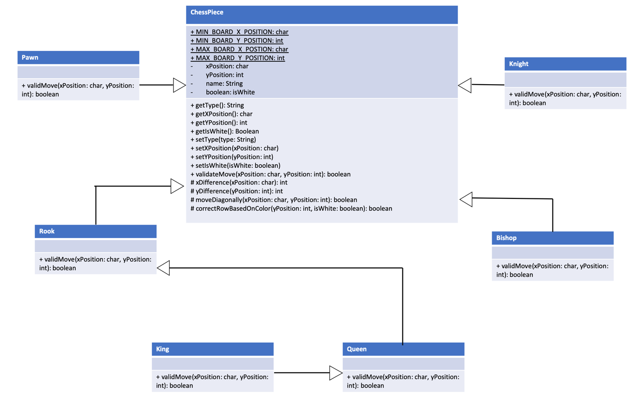

The next UML diagram demonstrates how ChessPiece, FileReader, PieceCreator, and Maldonado_Nichole_Lab3 all relate to each other. In the PieceCreator class, multiple instances of ChessPieces can be created, resulting in an aggregate relationship. Even when the PieceCreator class dies, the ChessPieces are used by the FileReader class. The FileReader class is the only class to create a PieceCreator object and thus a composition relationship ensues. The FileReader also has an array of ChessPieces, however, if it were to die the ChessPieces would still exist in the main program, which extracts the ChessPieces from the FileReader. This results in the ChessPiece and FileReader having an aggregate relationship. As for the Maldonado_Nichole_Lab3, its birth and death causes a FileReader object to be created and consequently ChessPiece derived class objects to be created. This in turn describes a composition relationship.

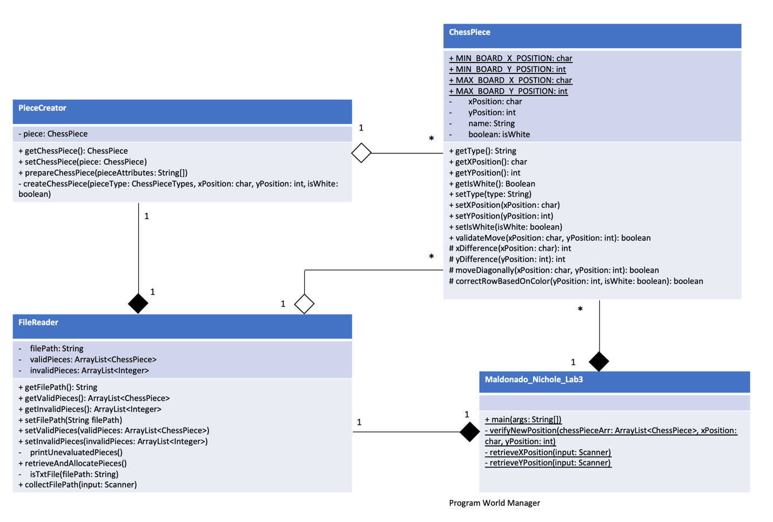

The enumeration, ChessPieceTypes, is used by the PieceCreator class and thus results in a dependency relationship.

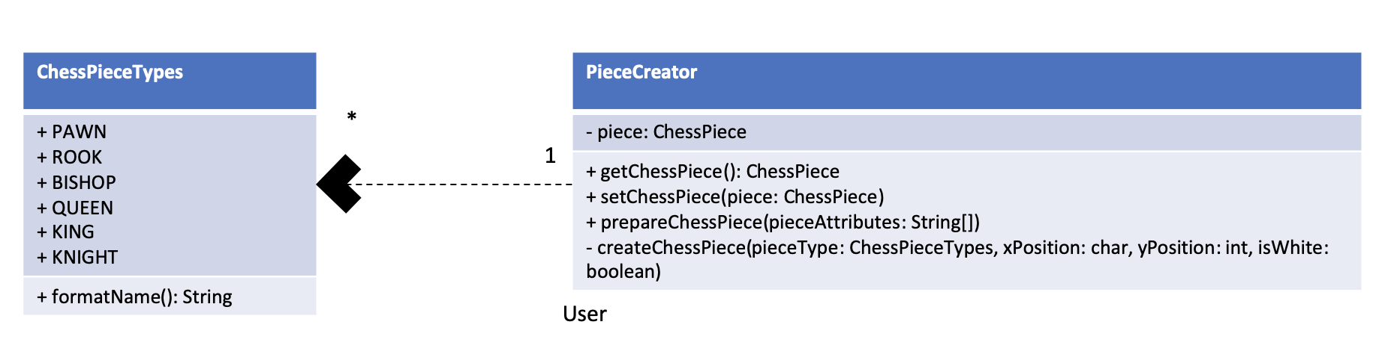

**Appendix**

Maldonado_Nichole_Lab2.java

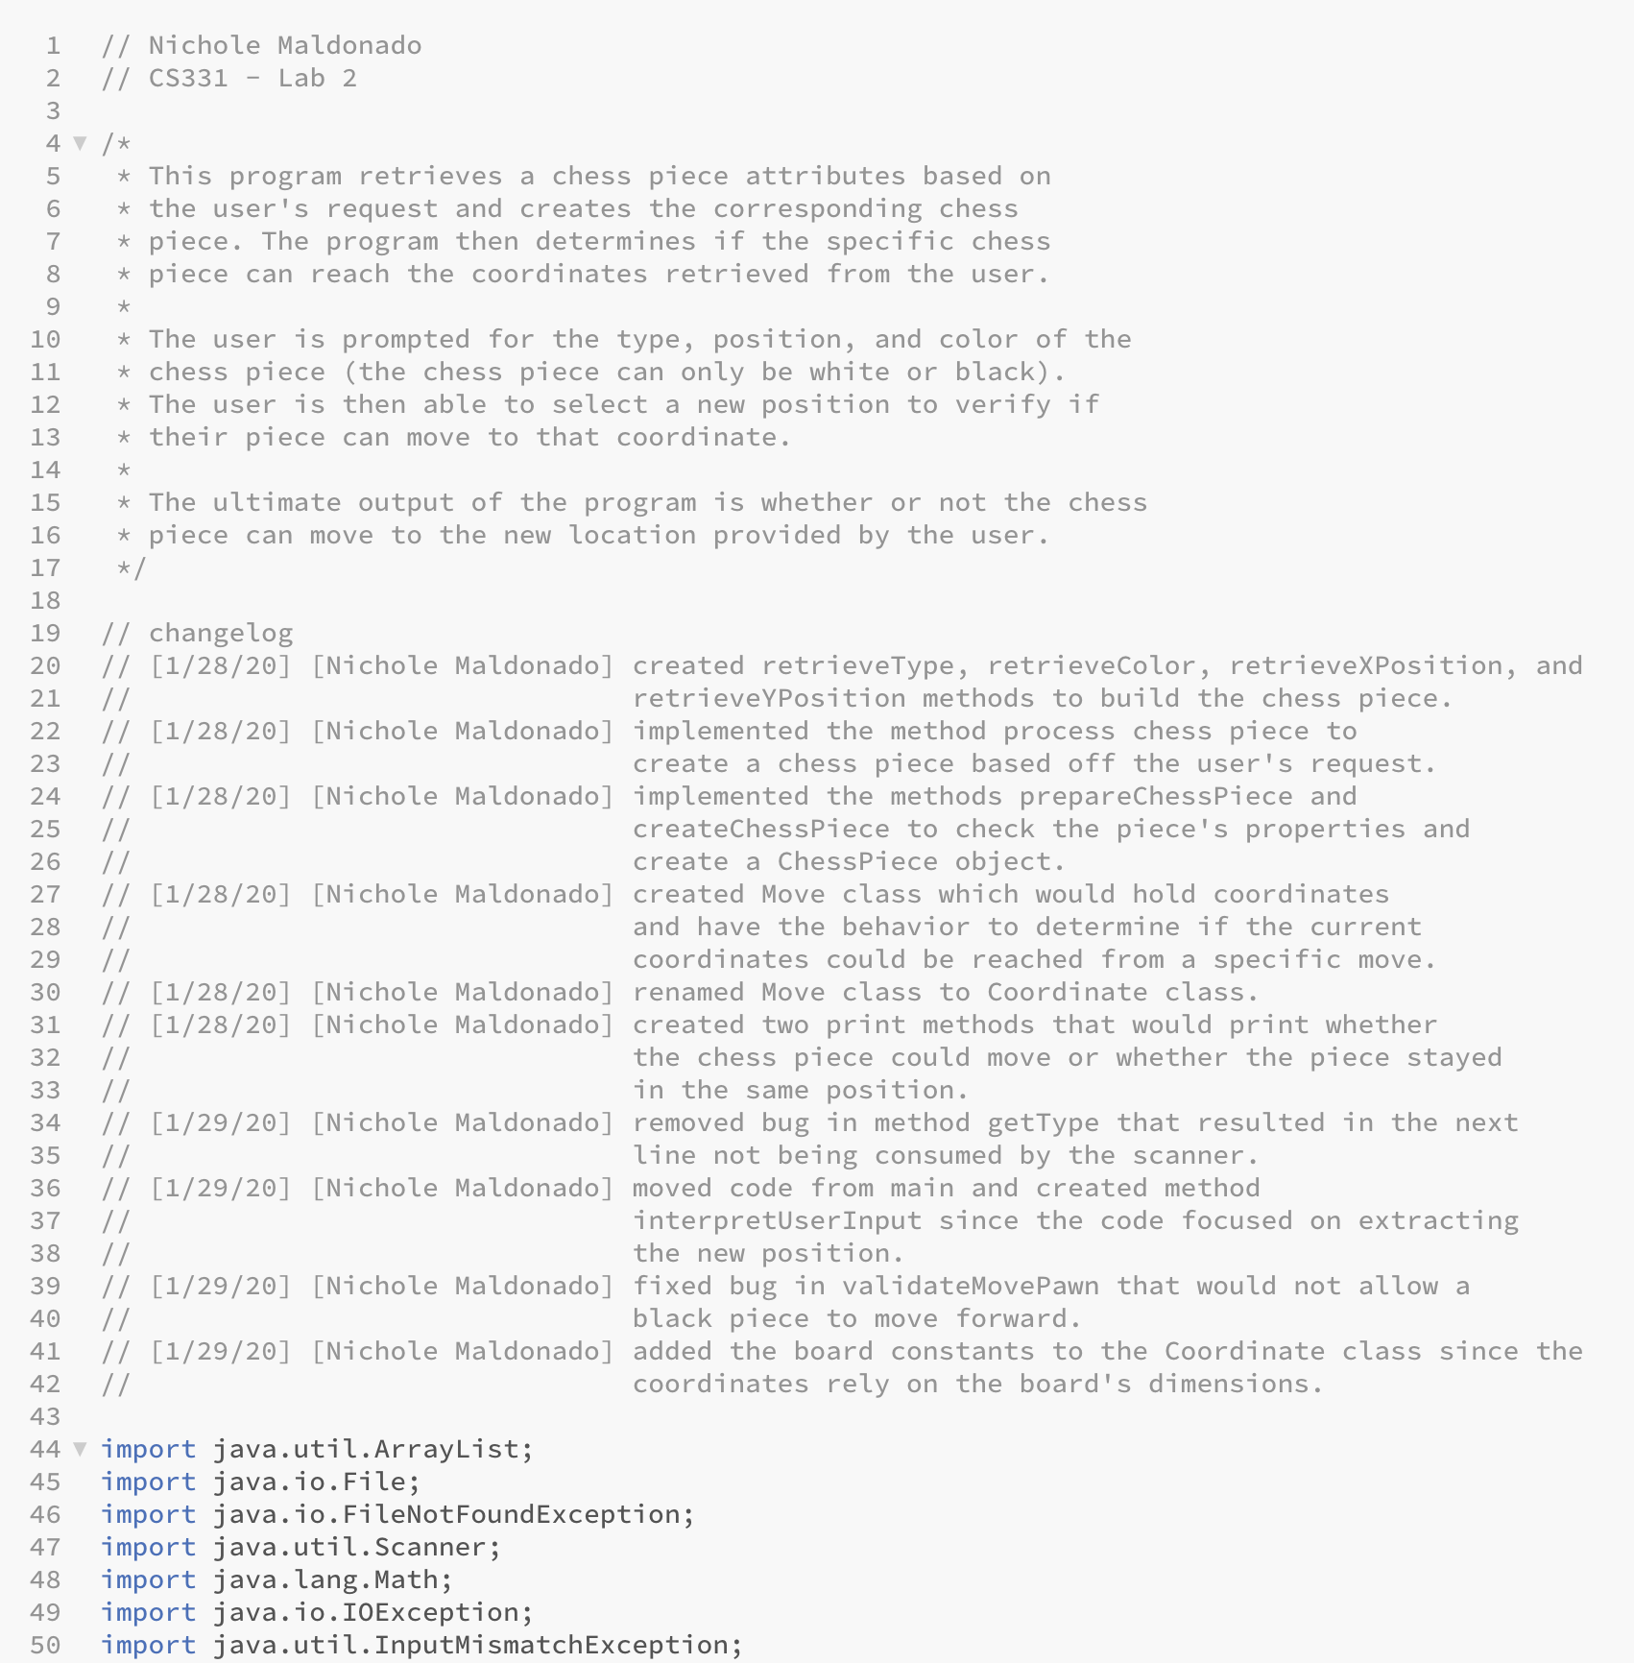

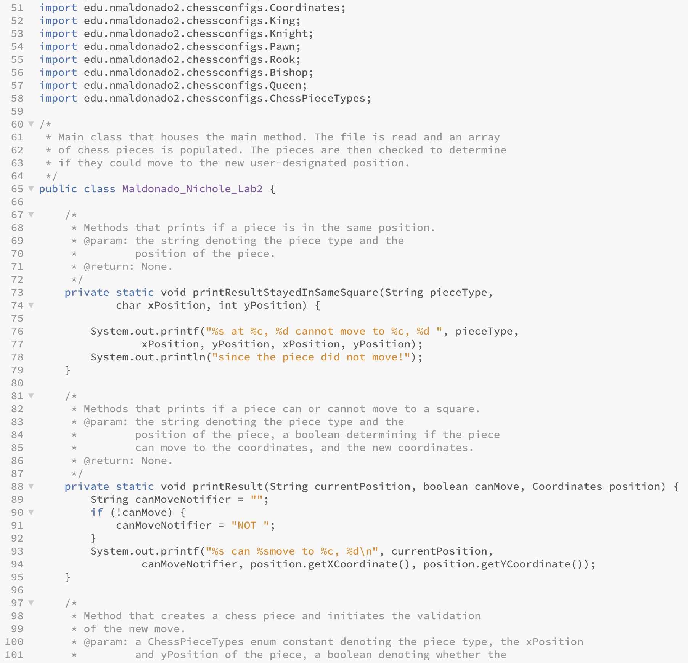

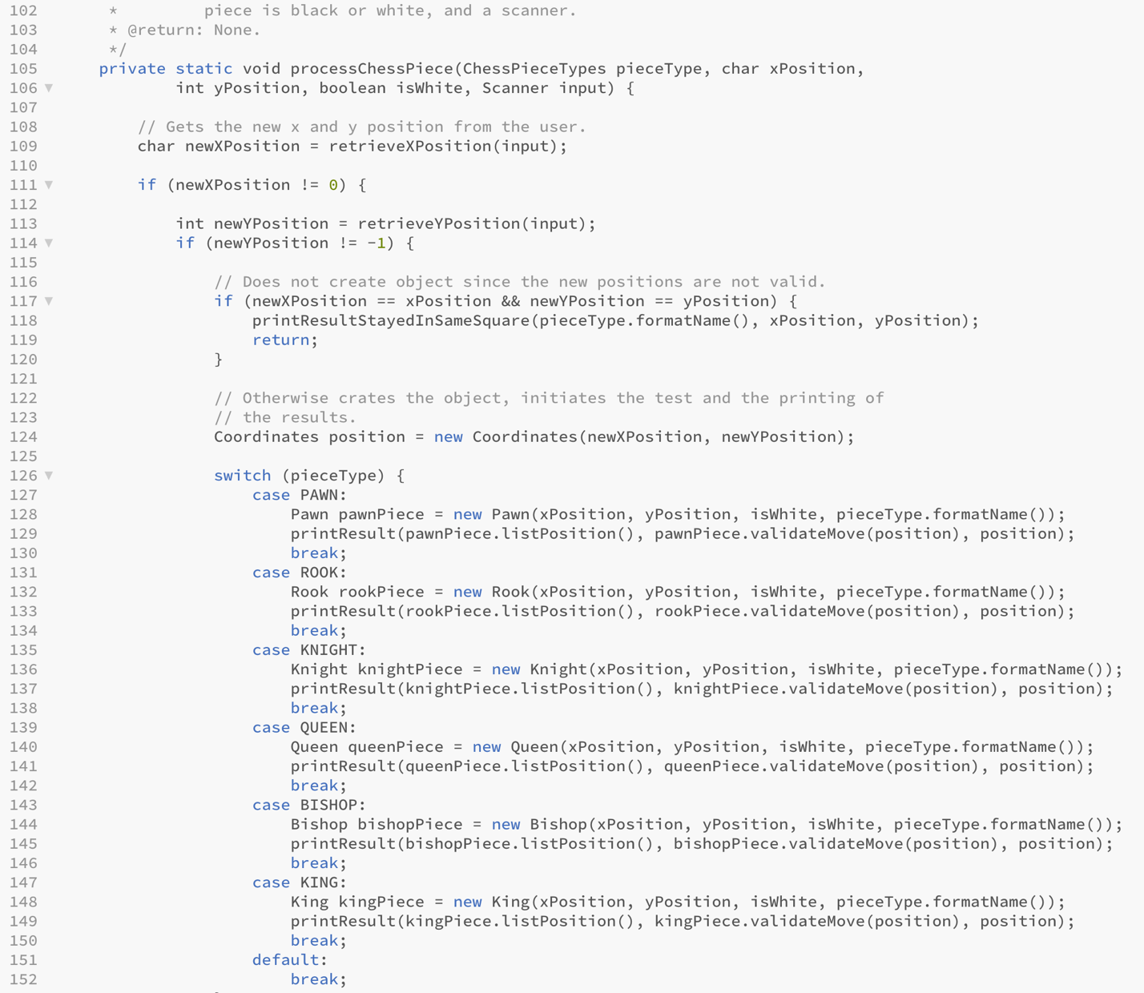

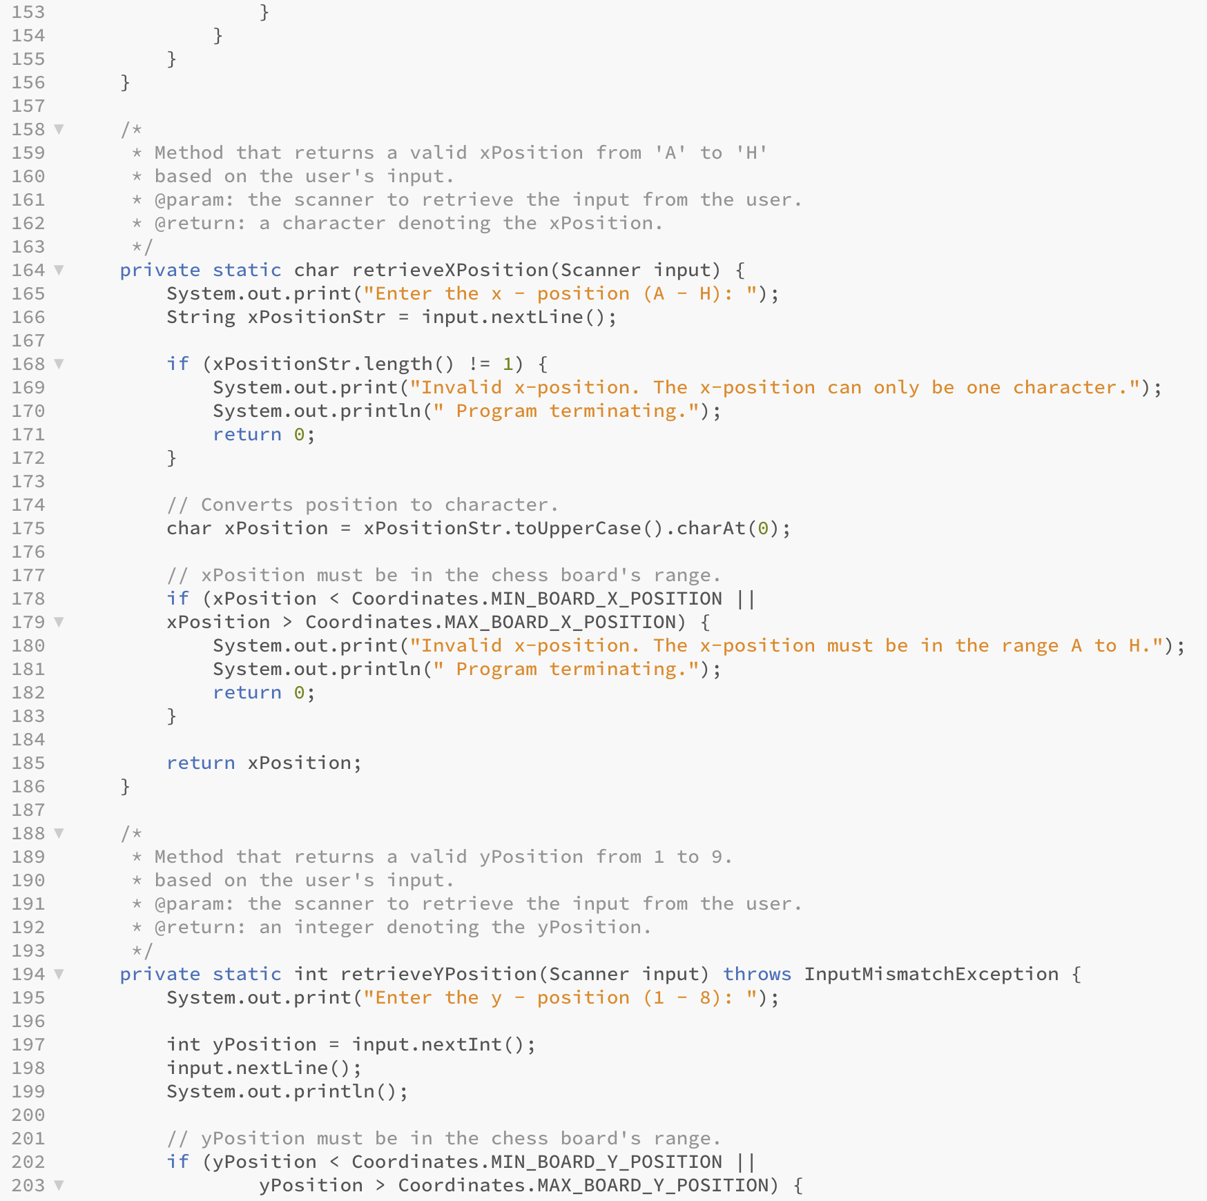

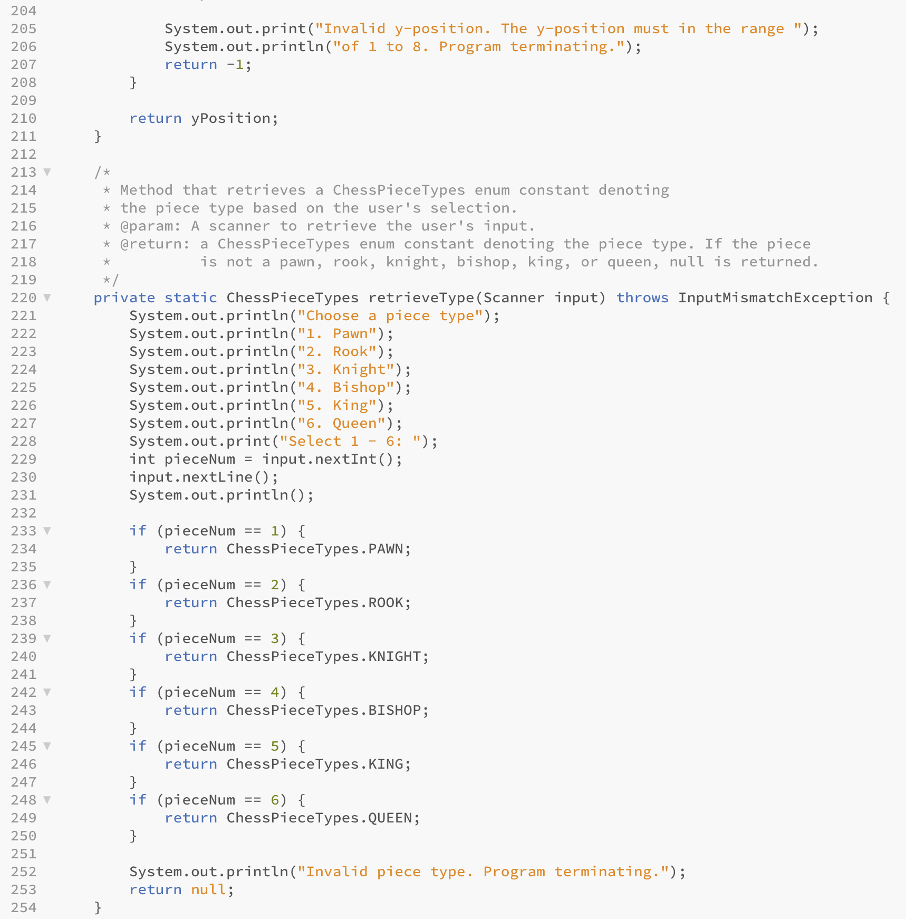

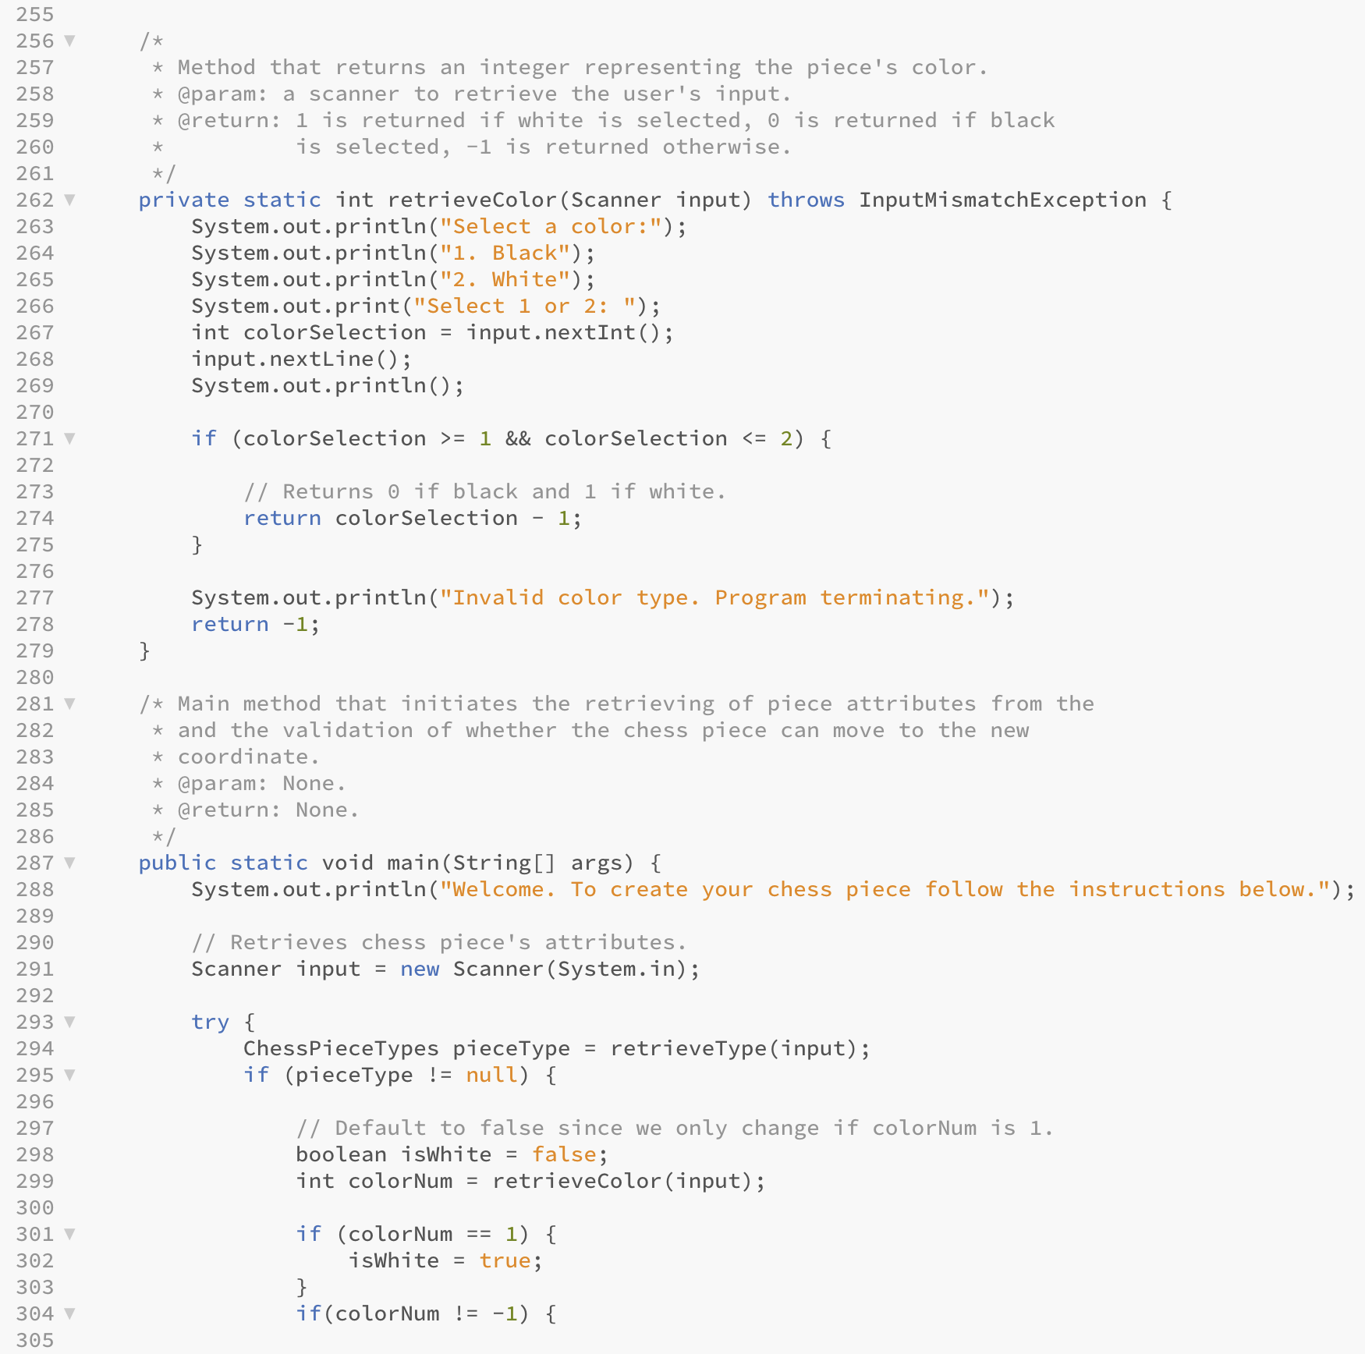

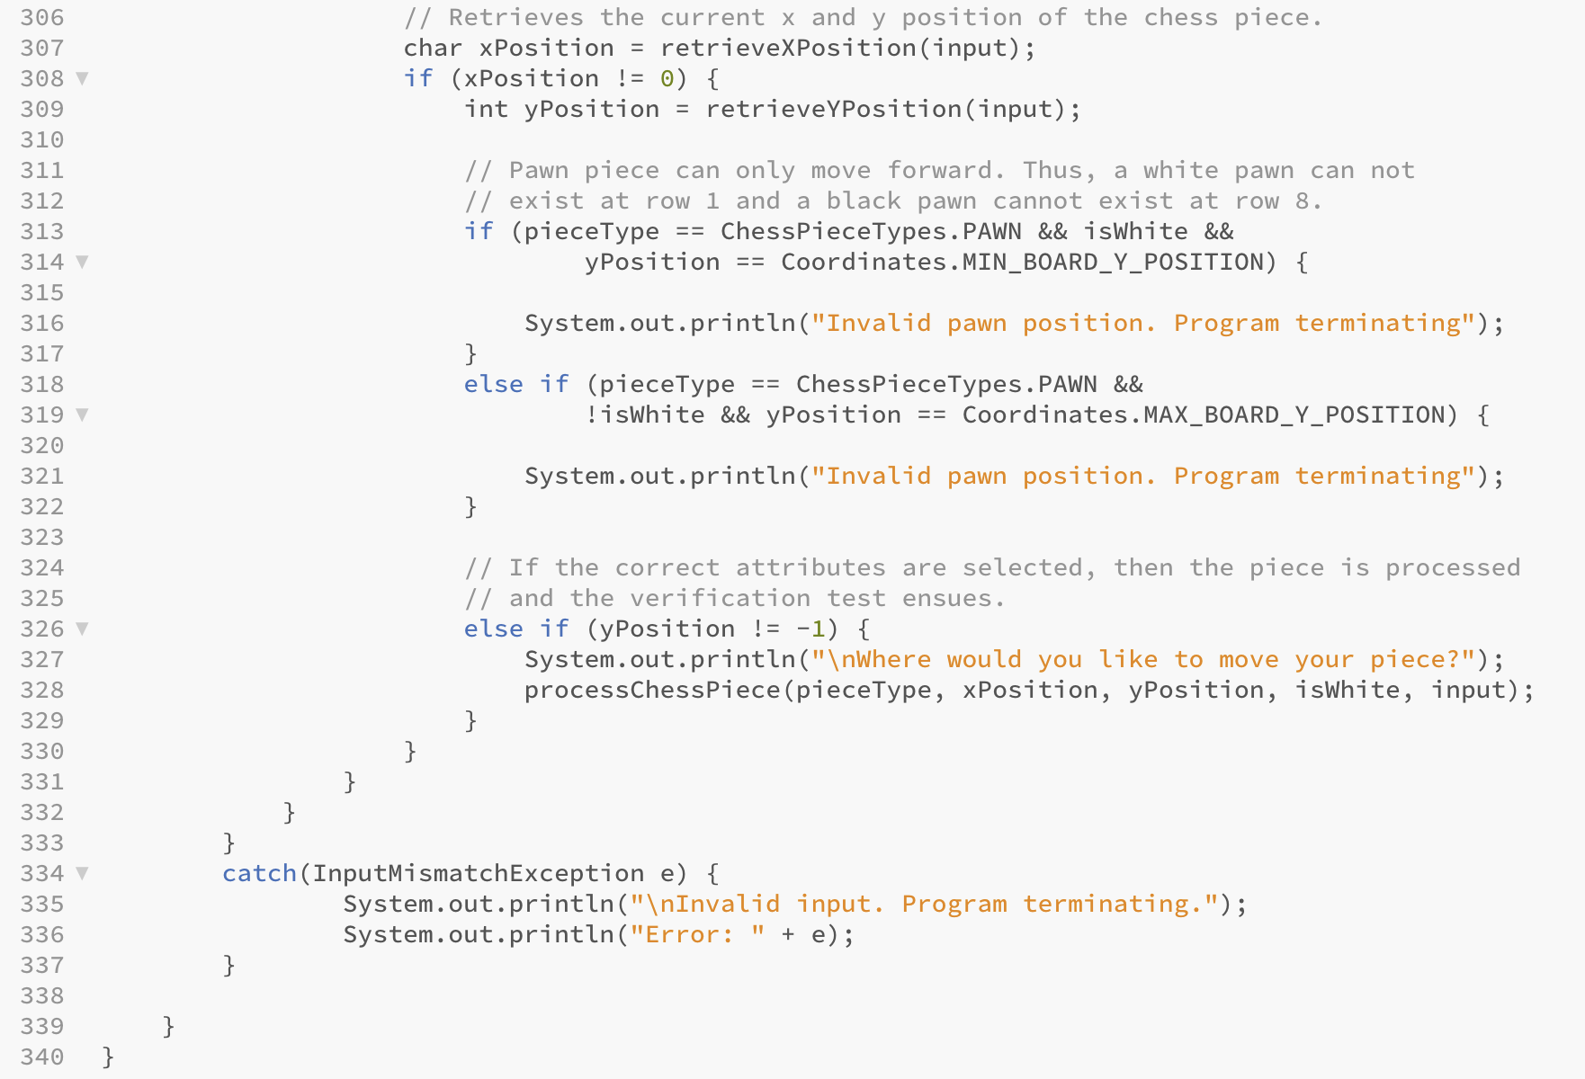

Pawn.java

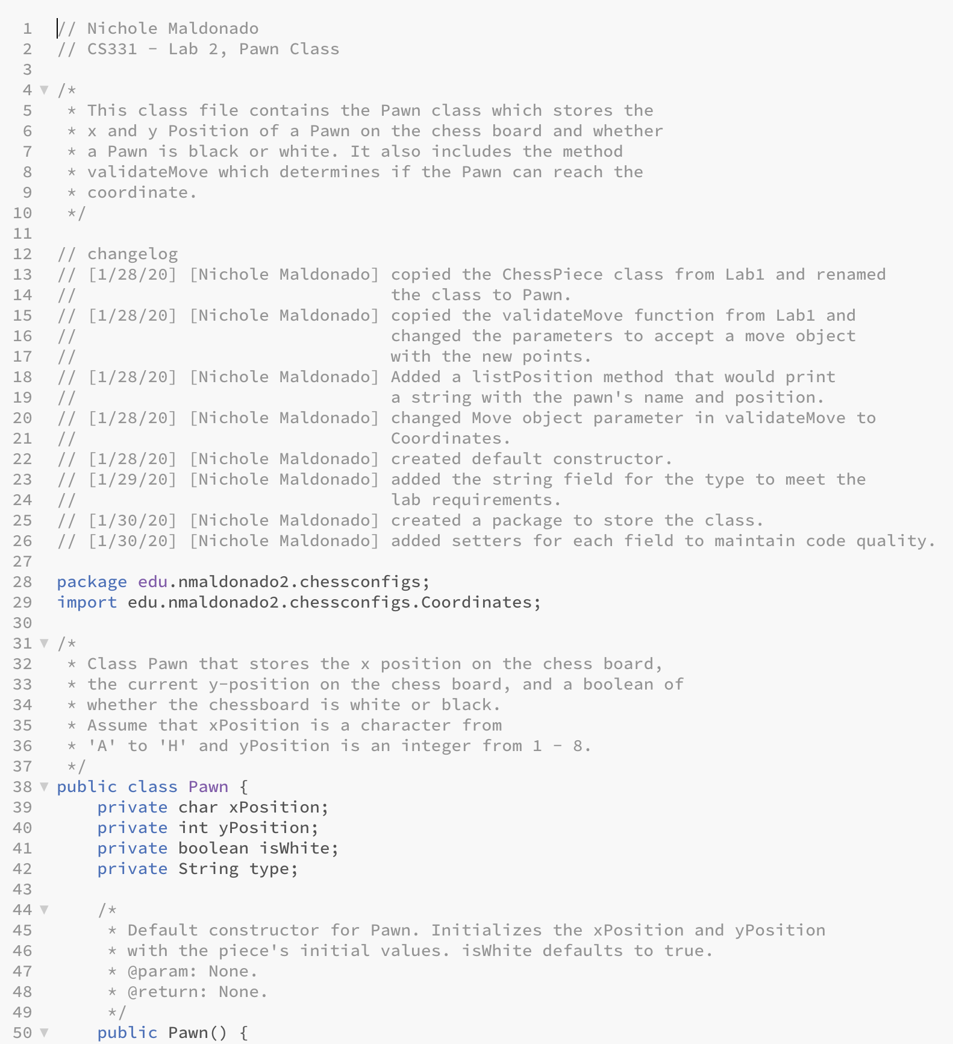

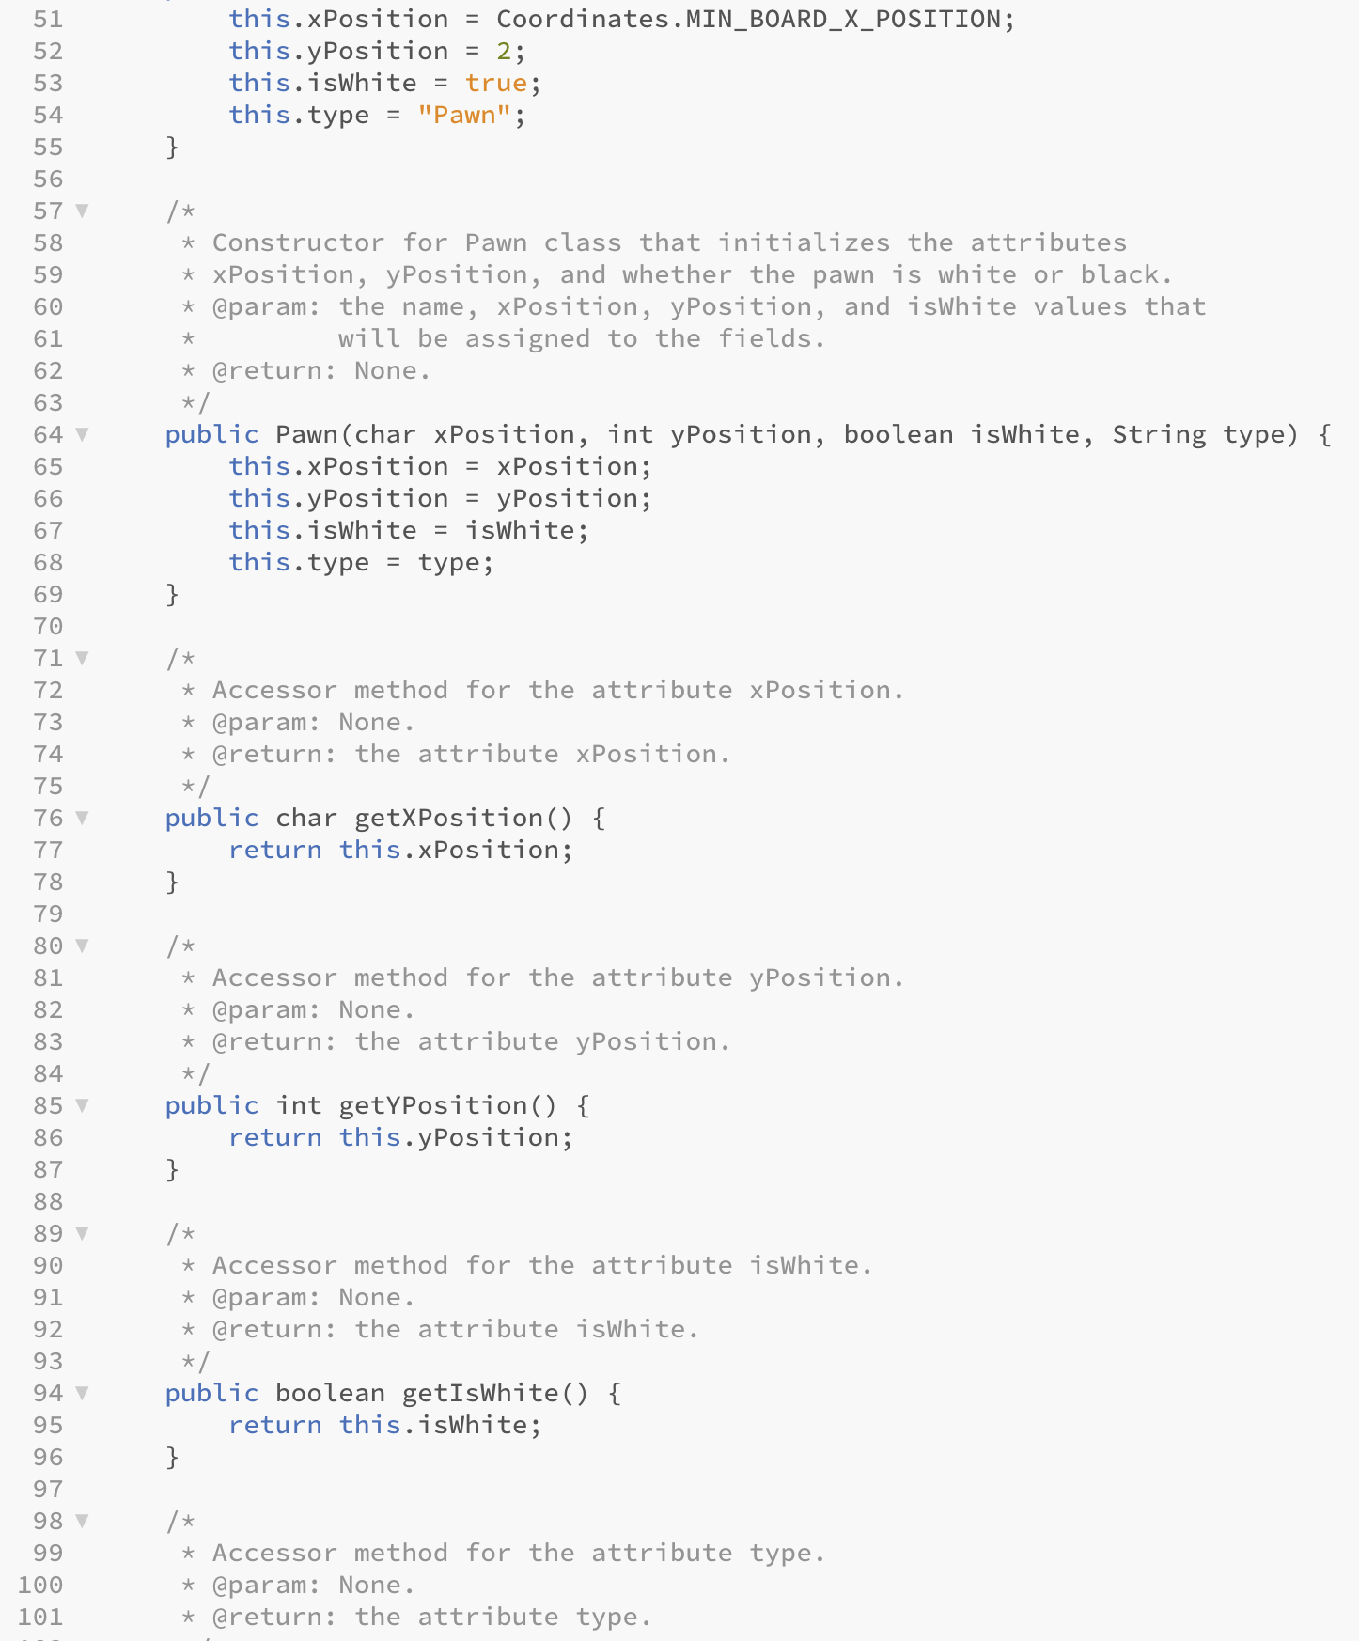

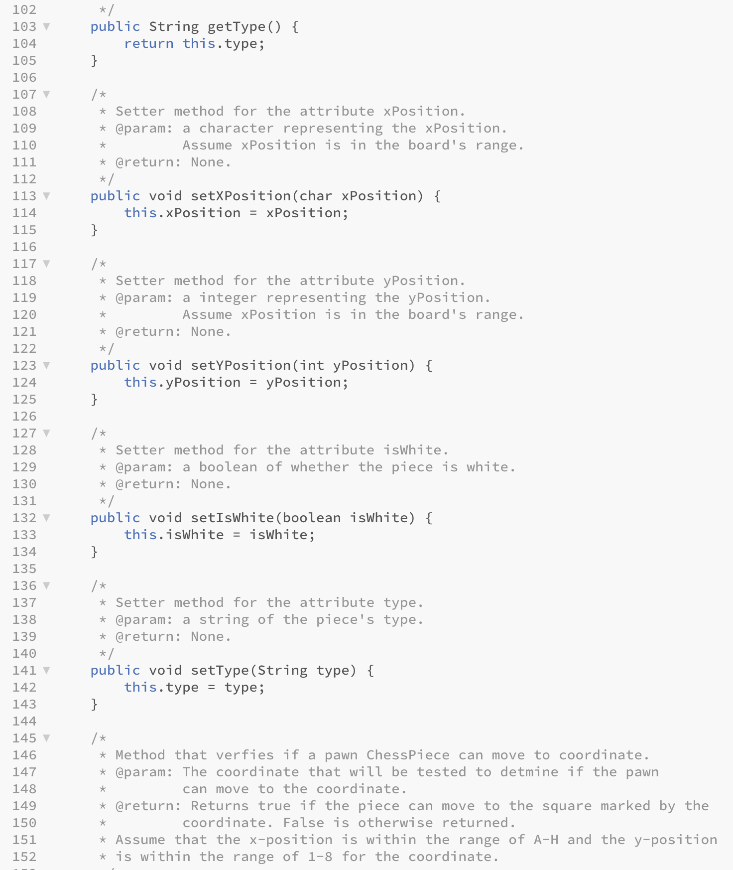

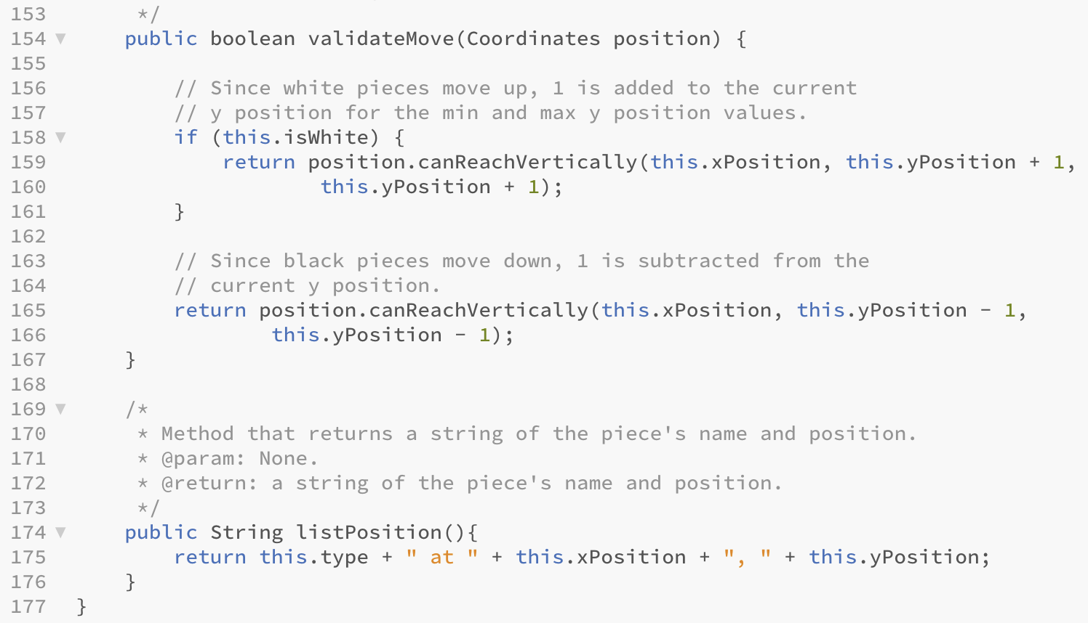

Rook.java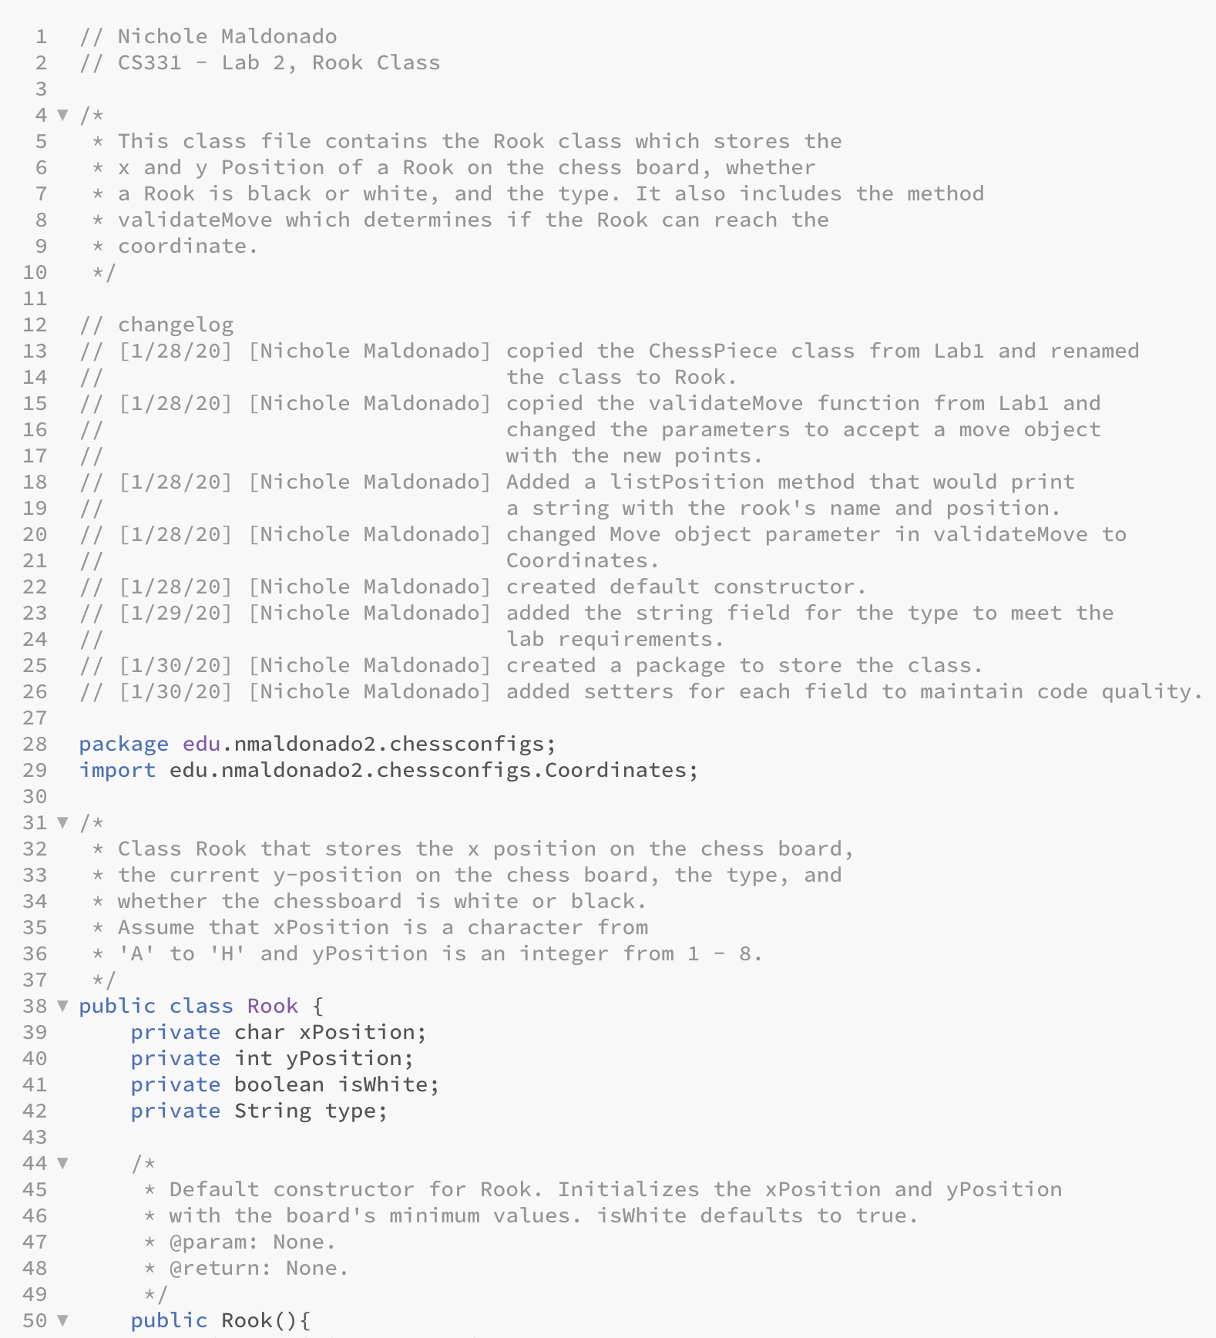

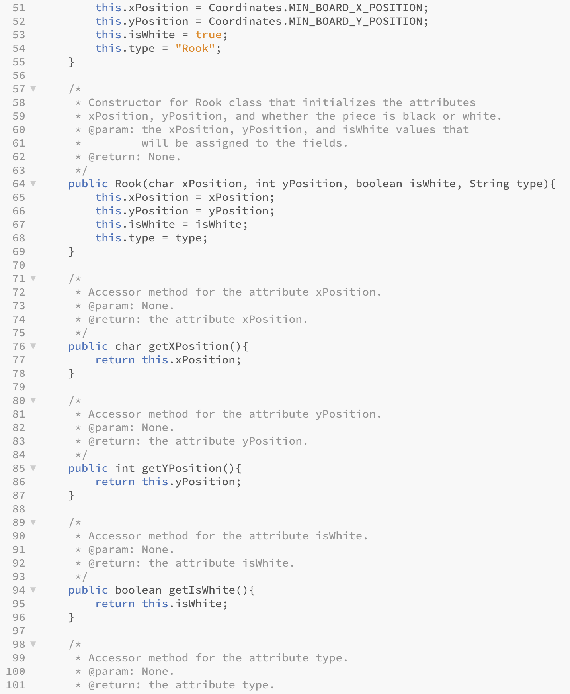

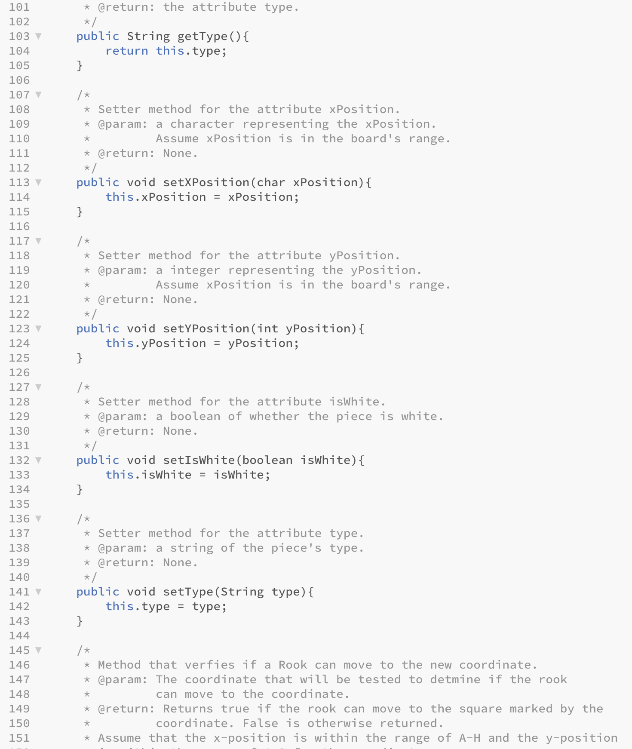

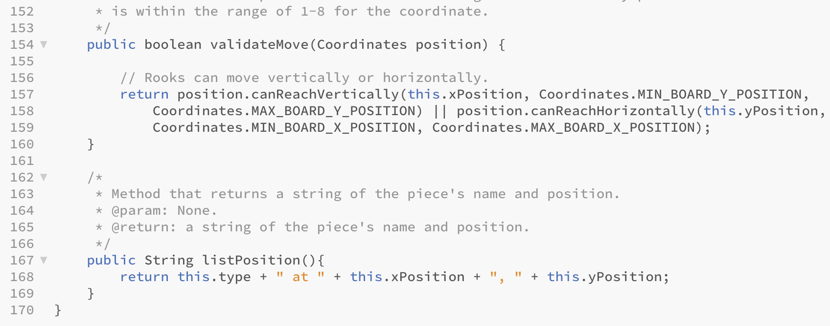

Bishop.java

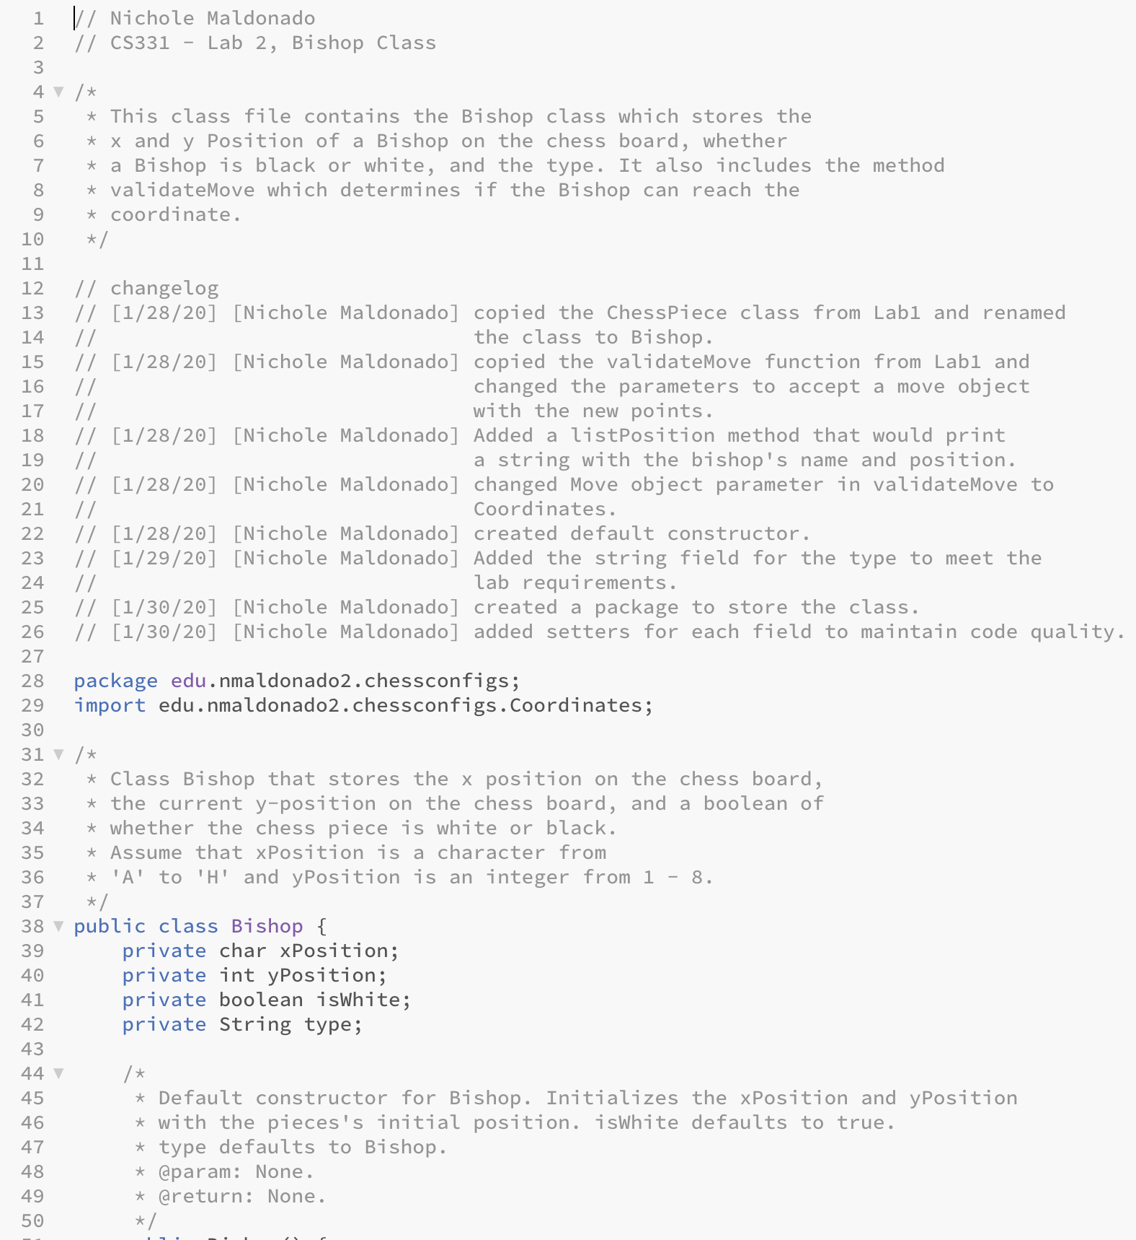

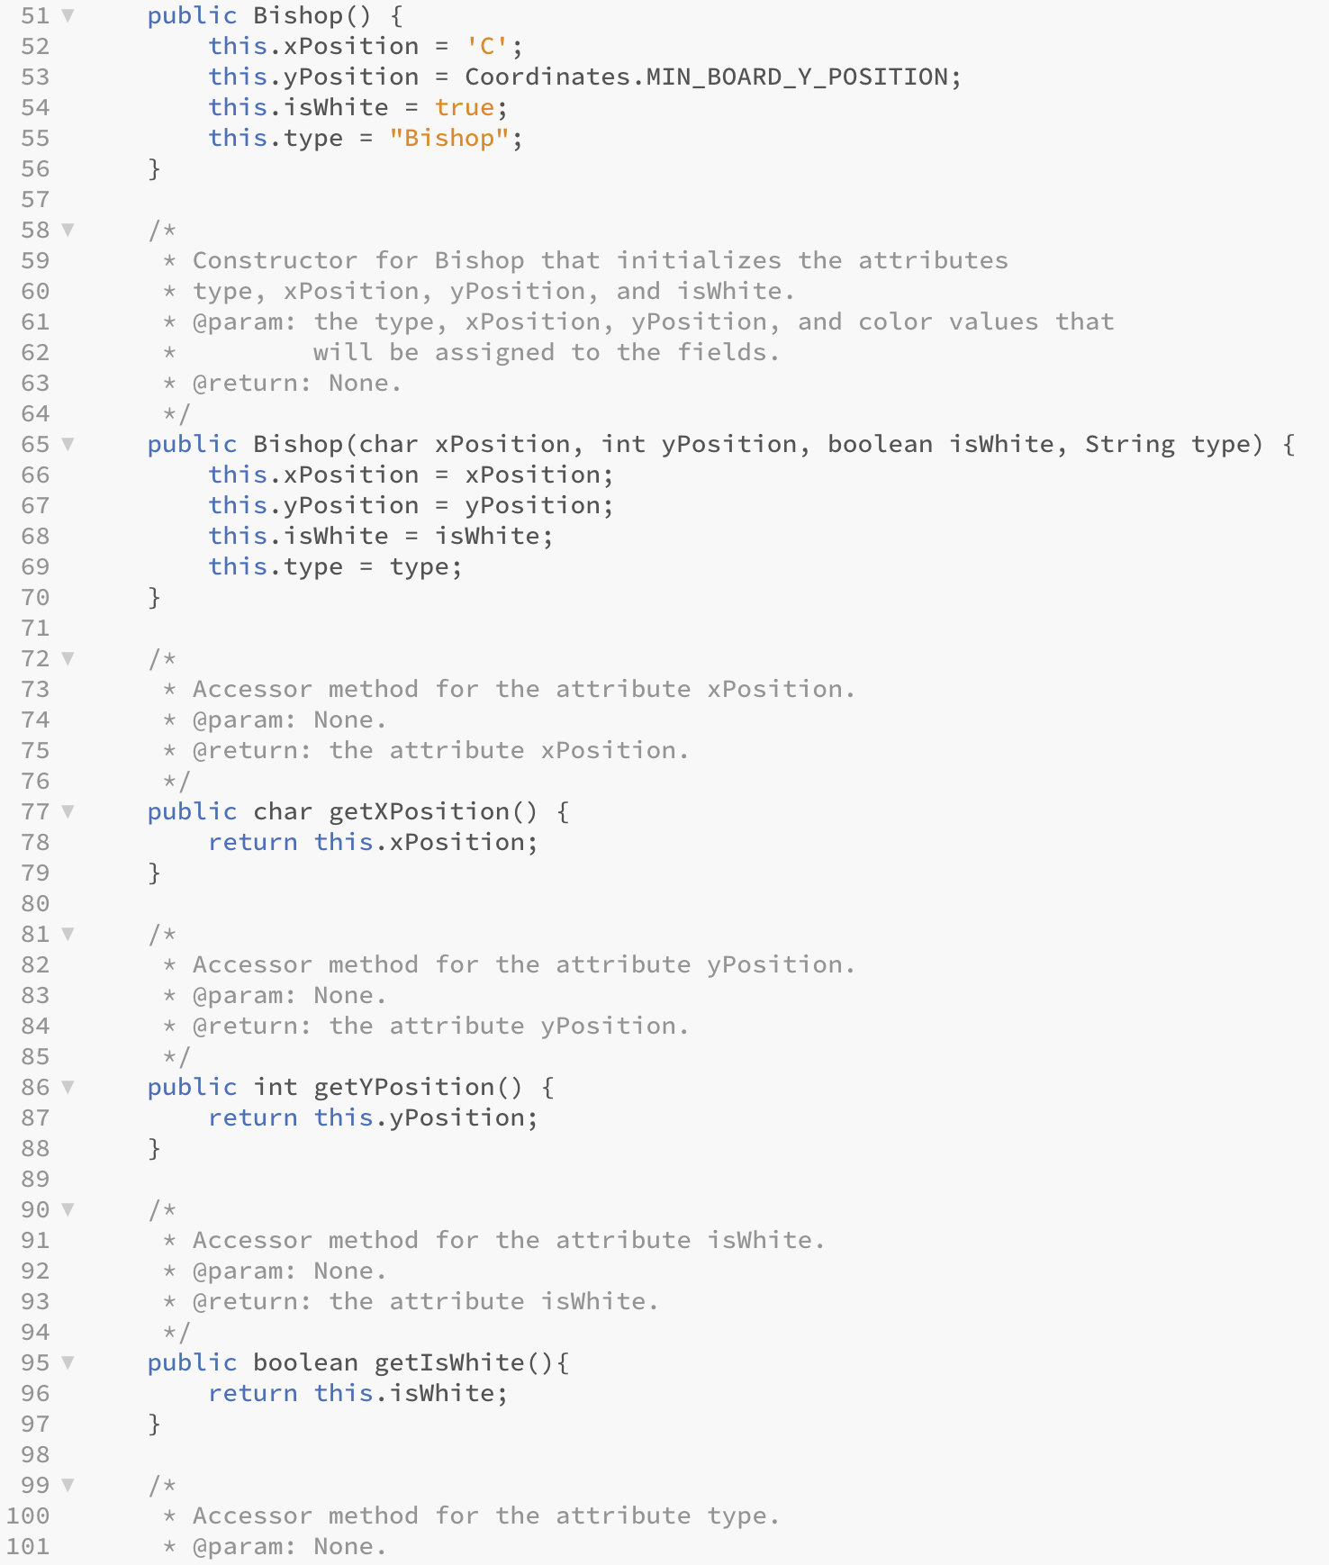

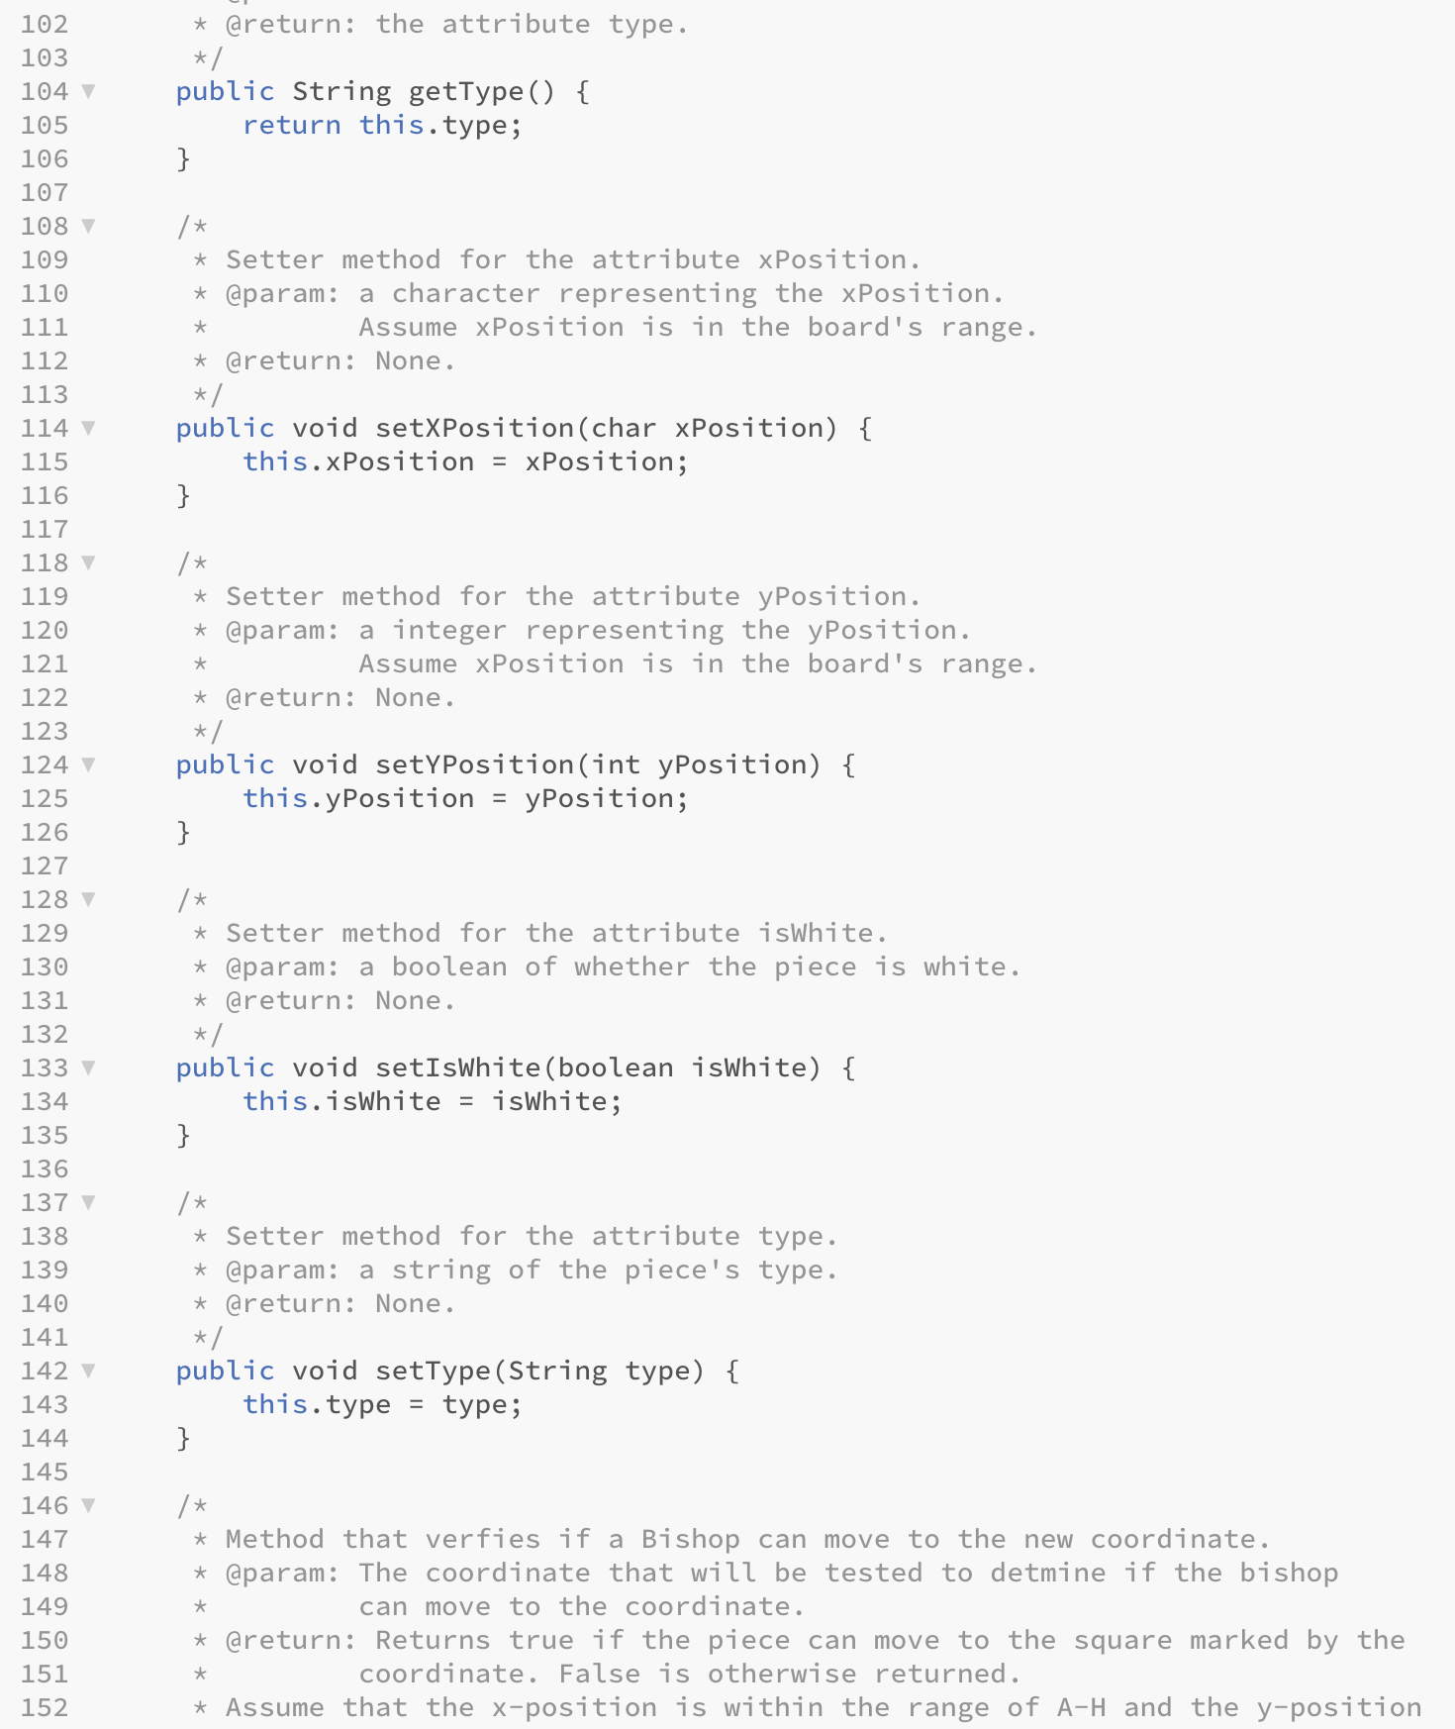

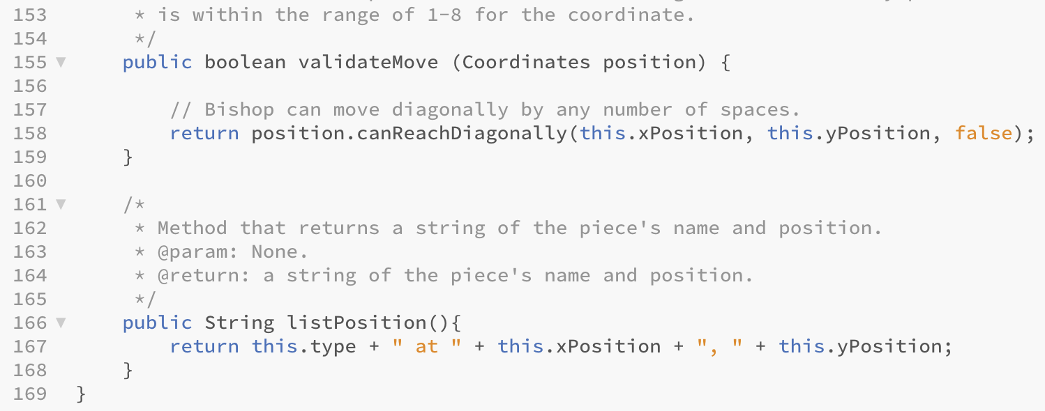

Knight.java

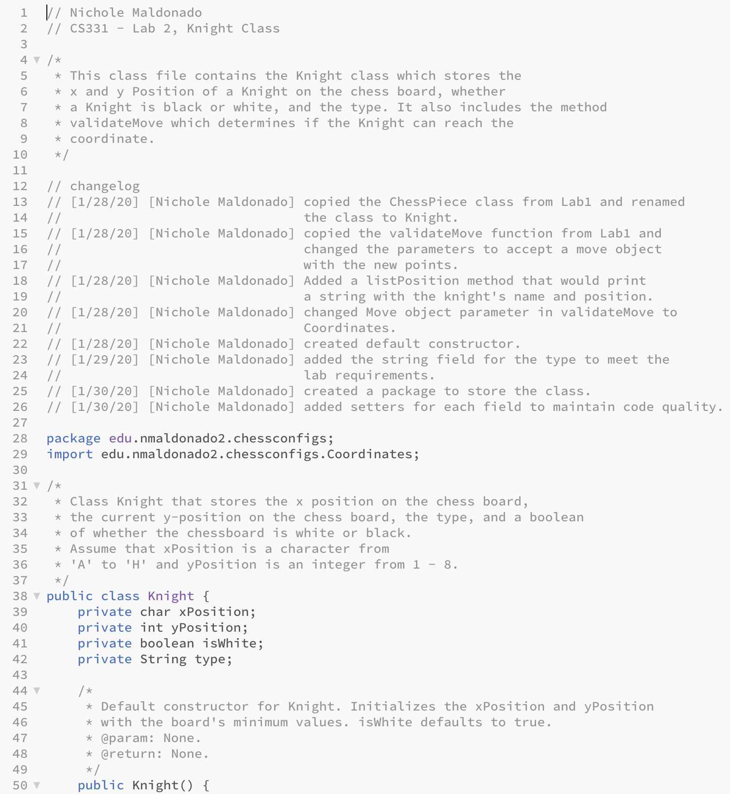

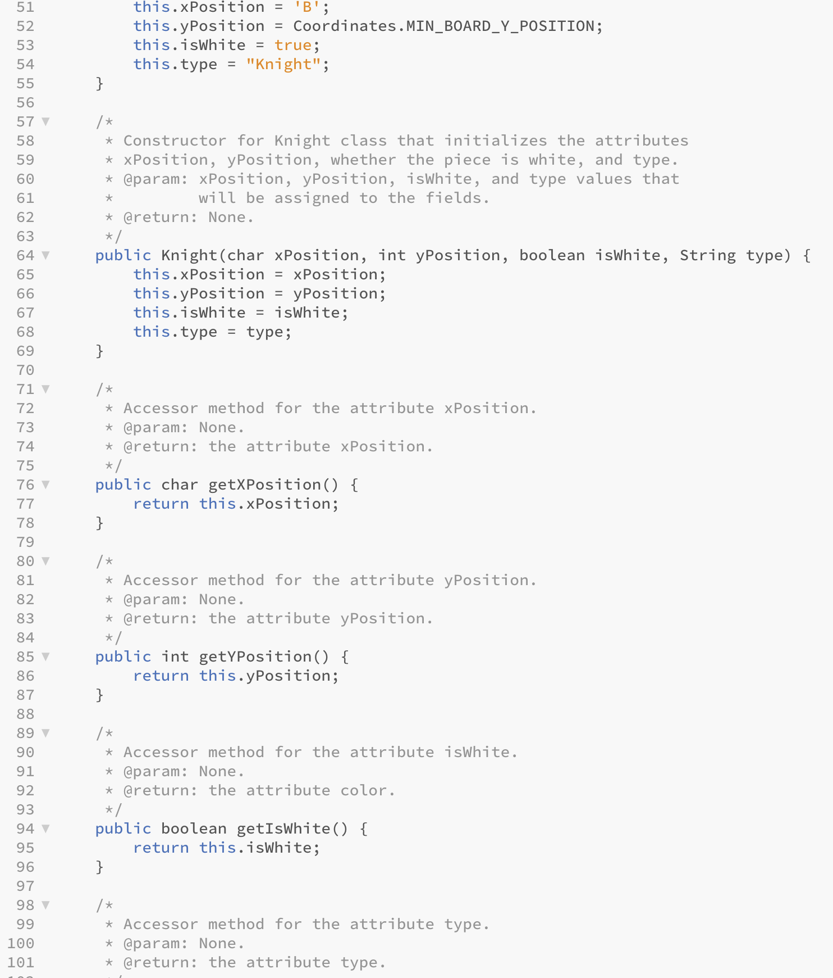

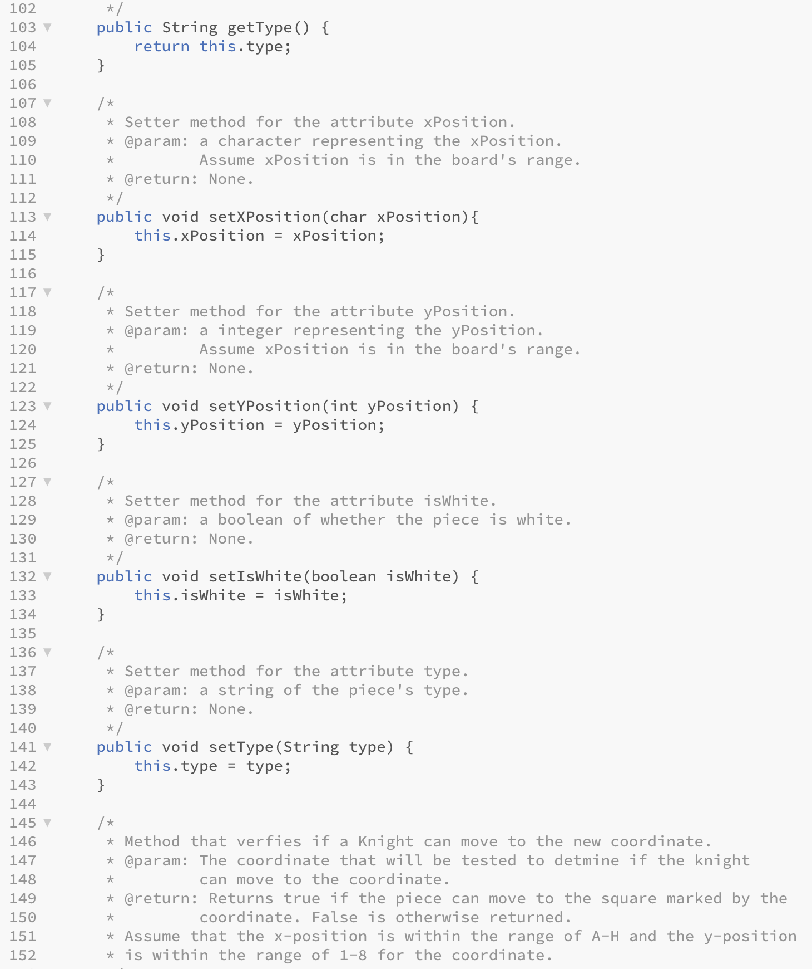

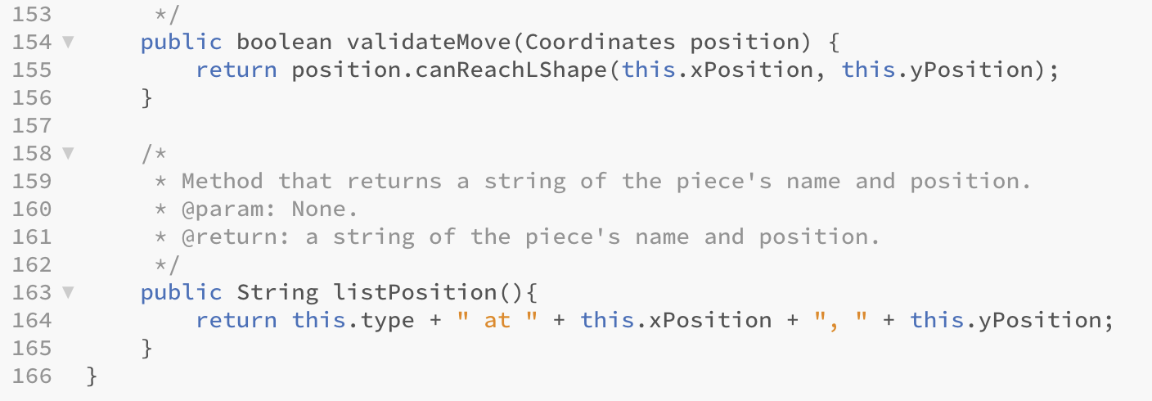

Queen.java

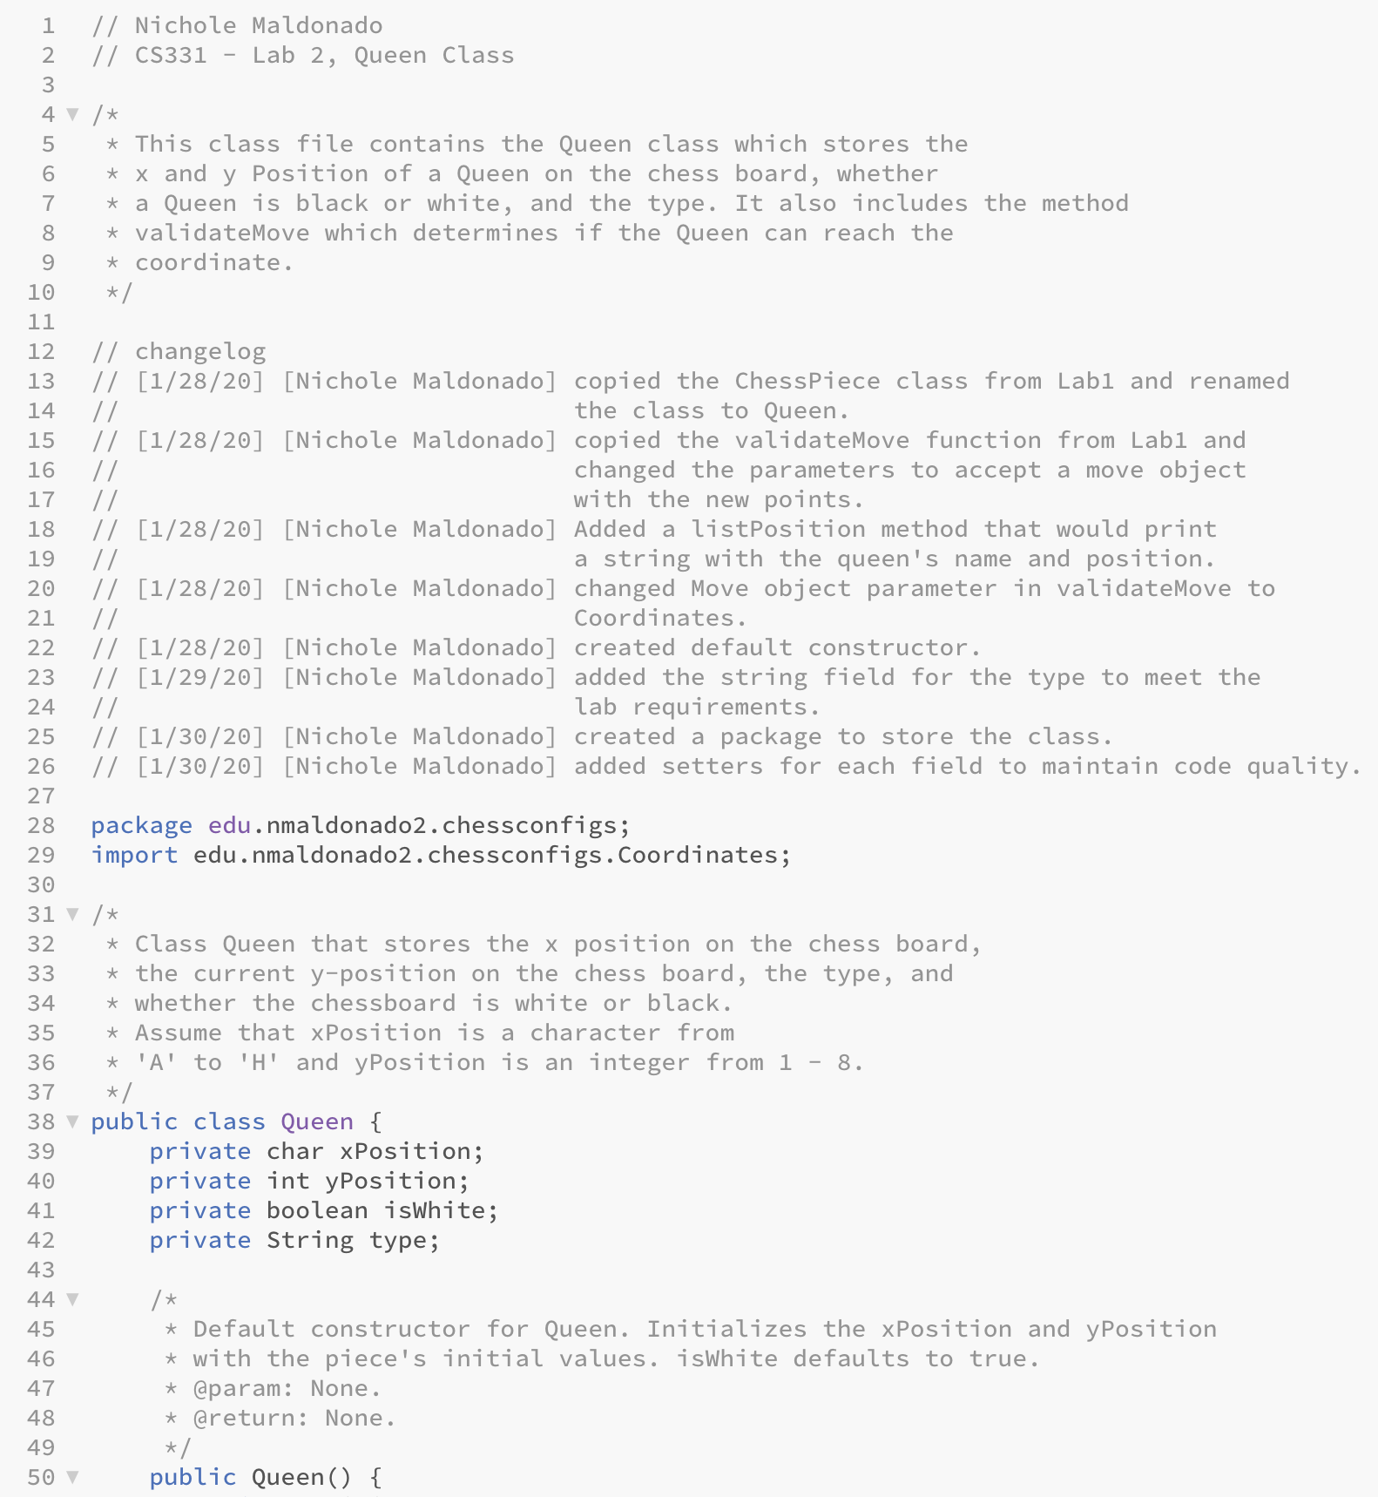

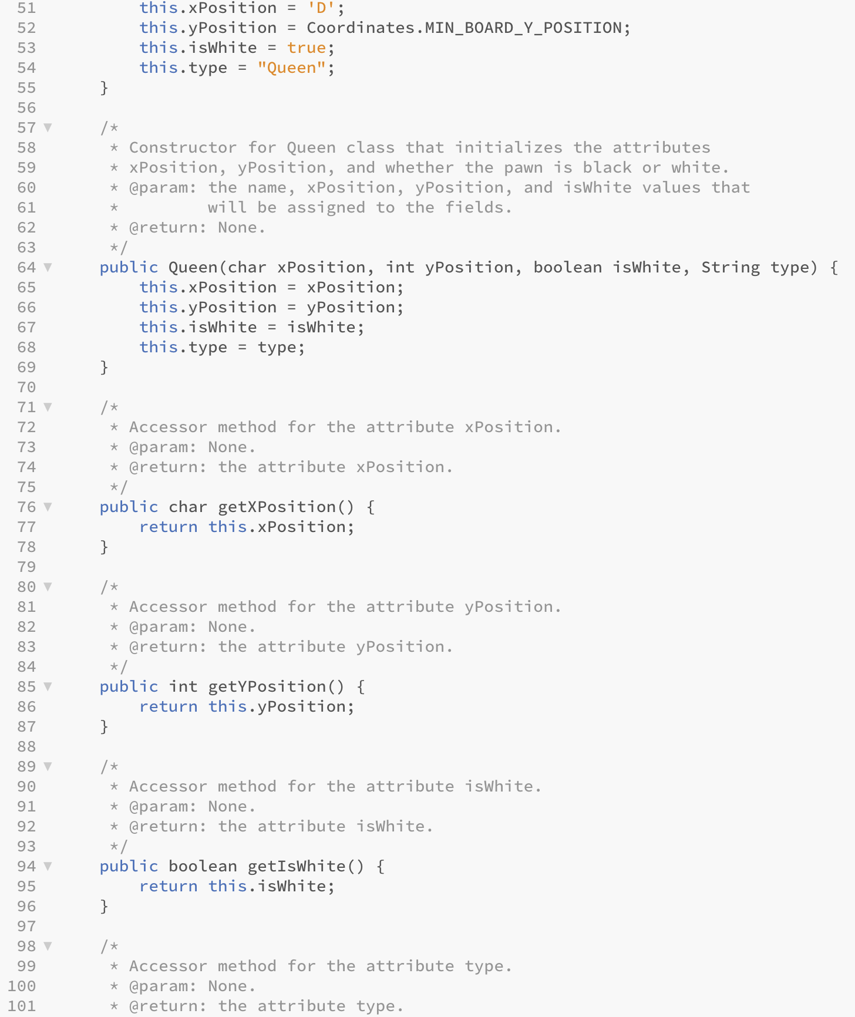

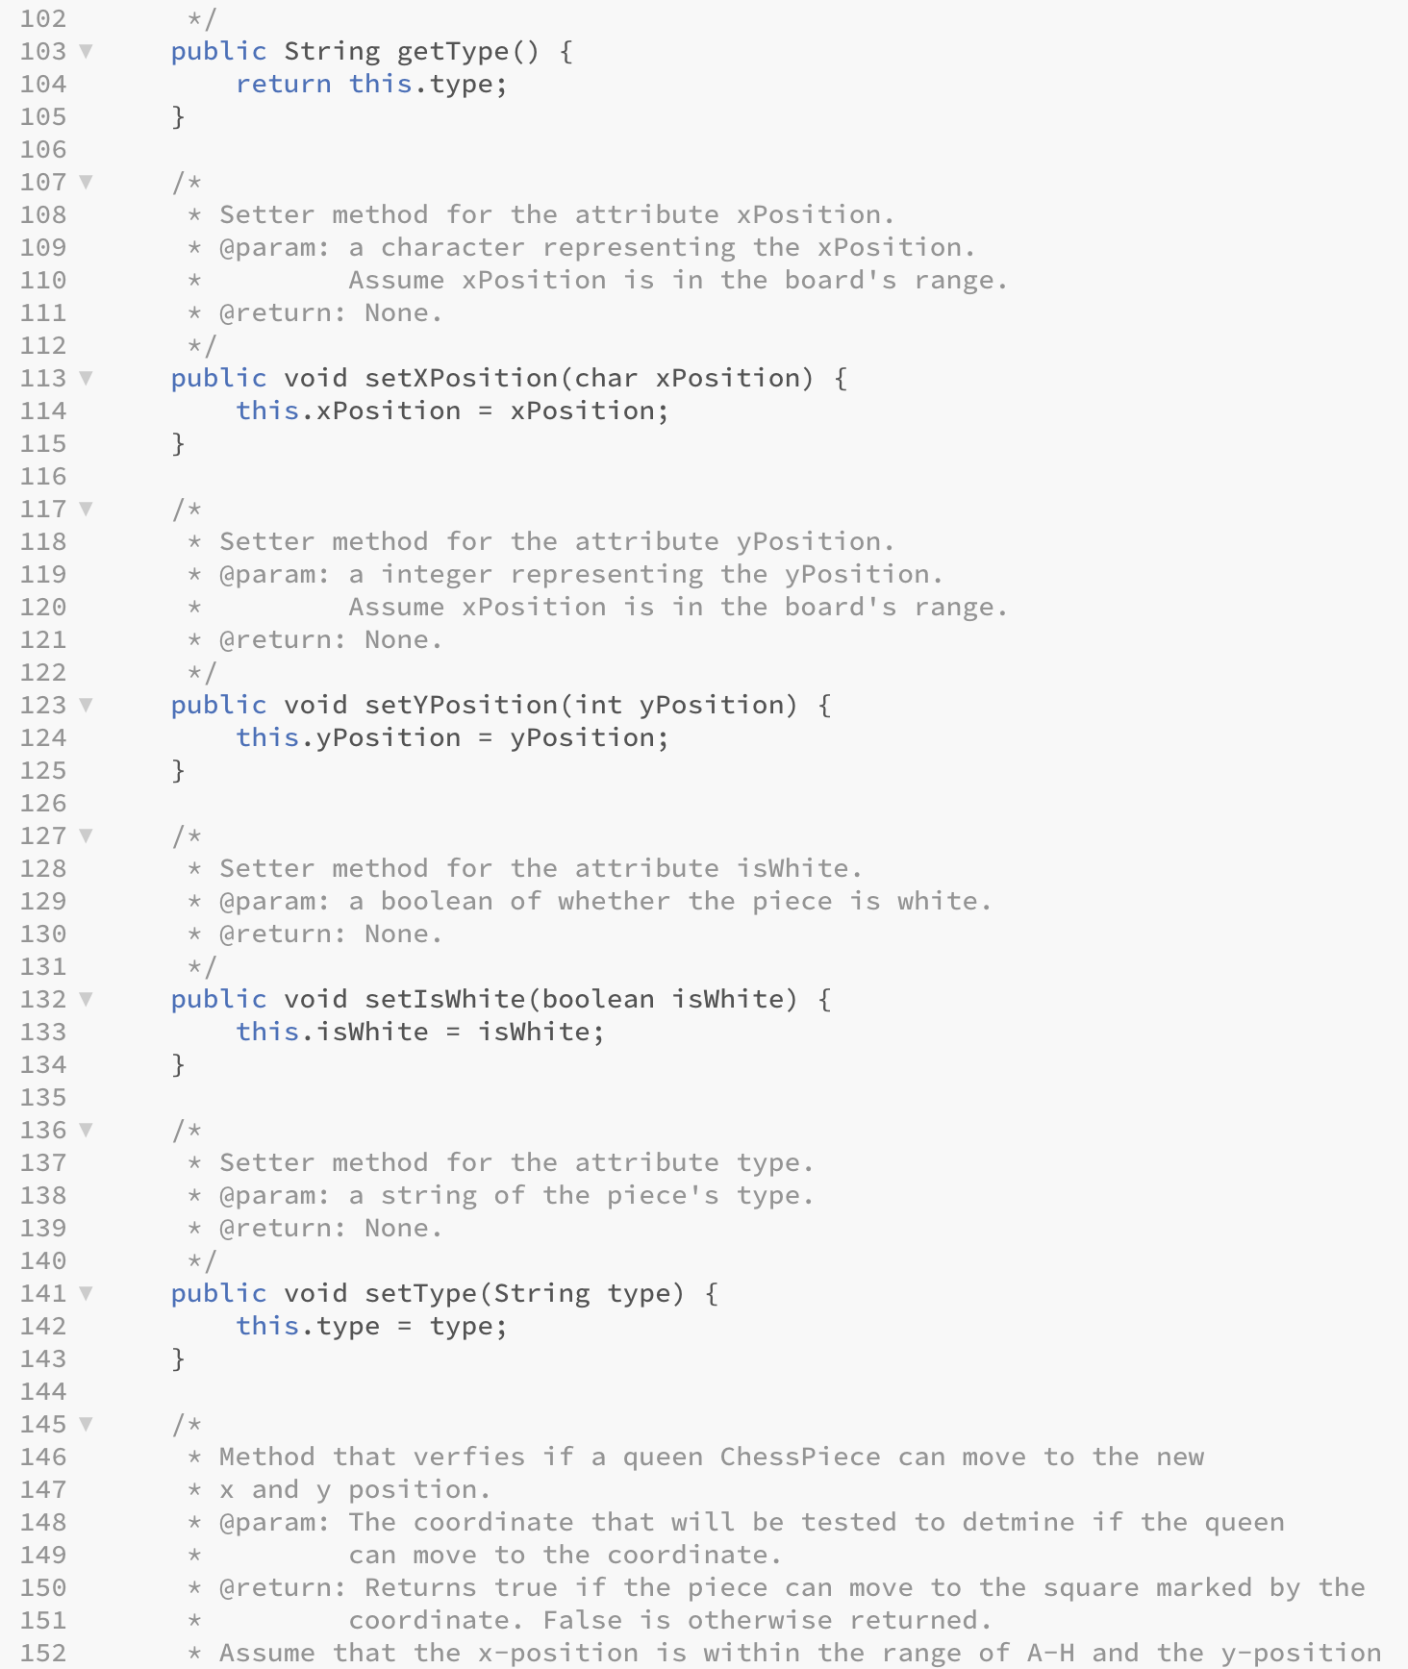

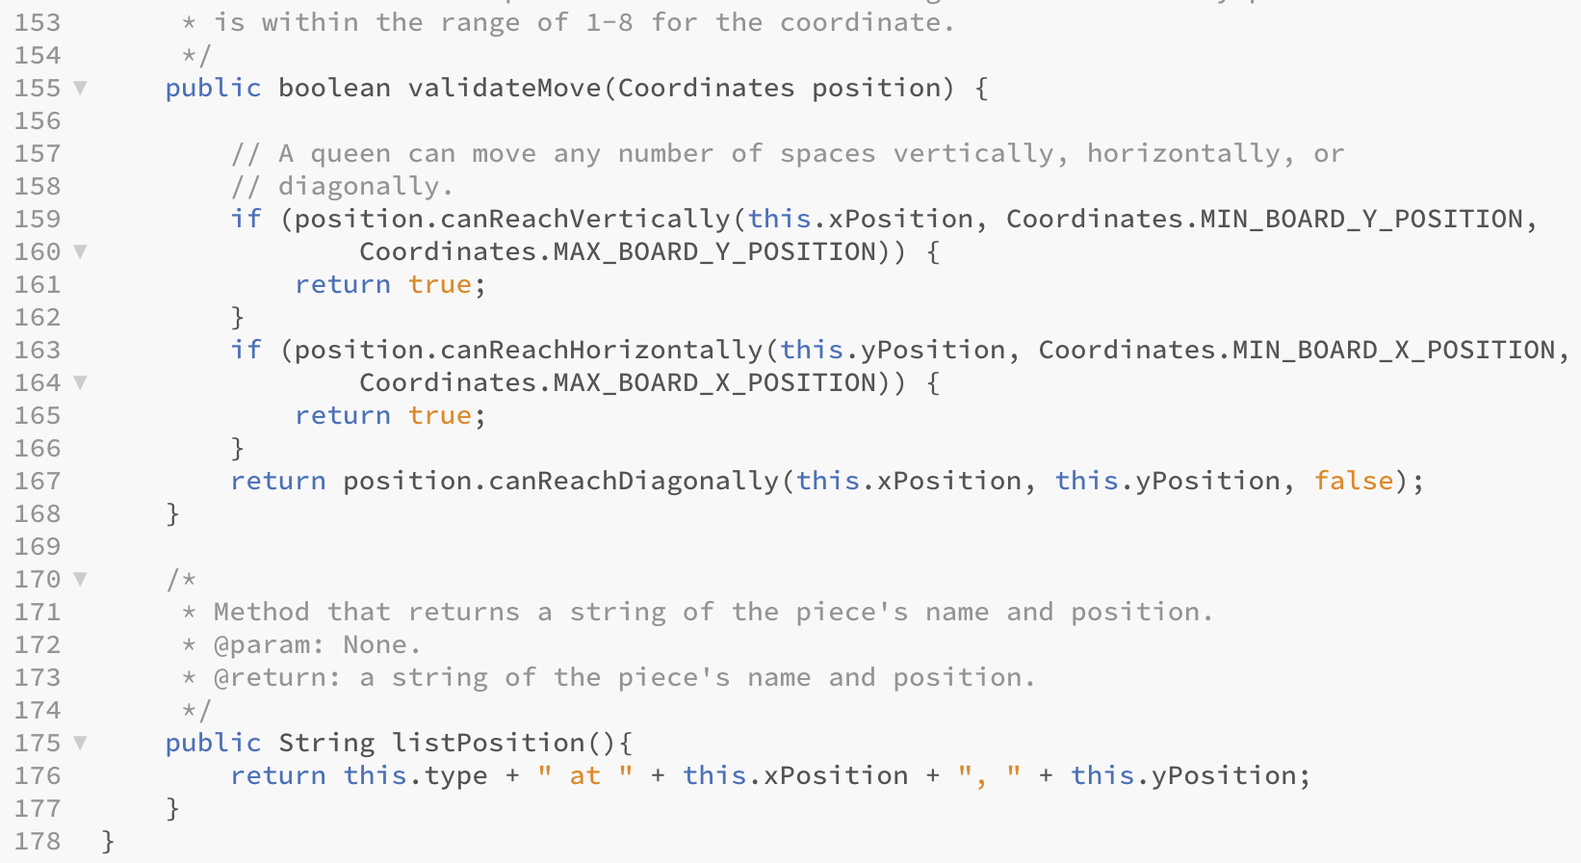

King.java

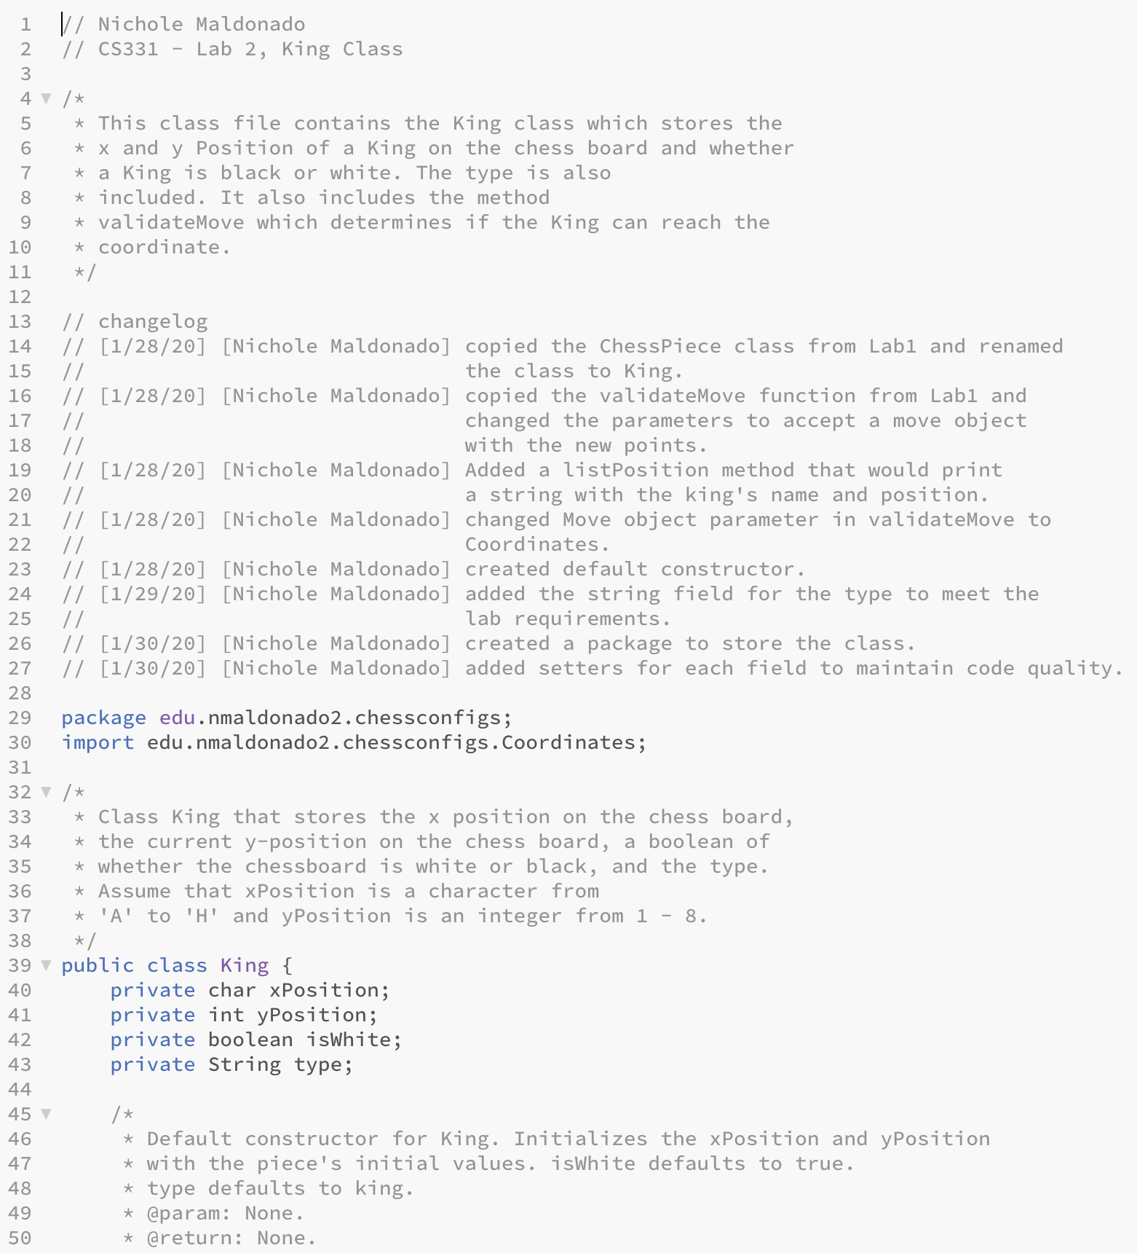

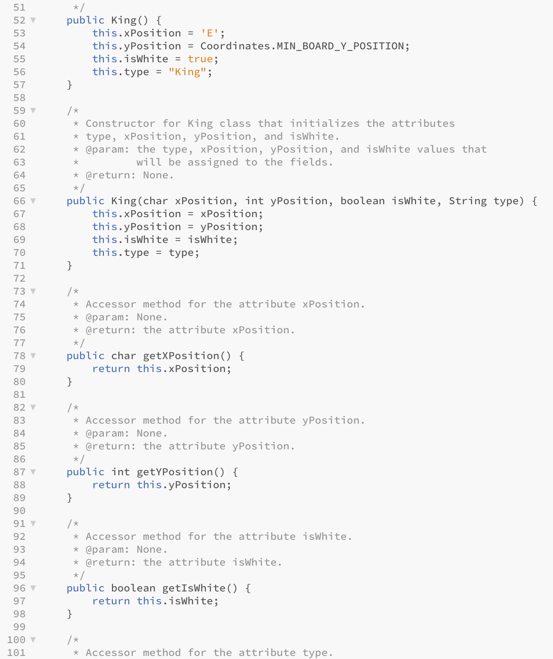

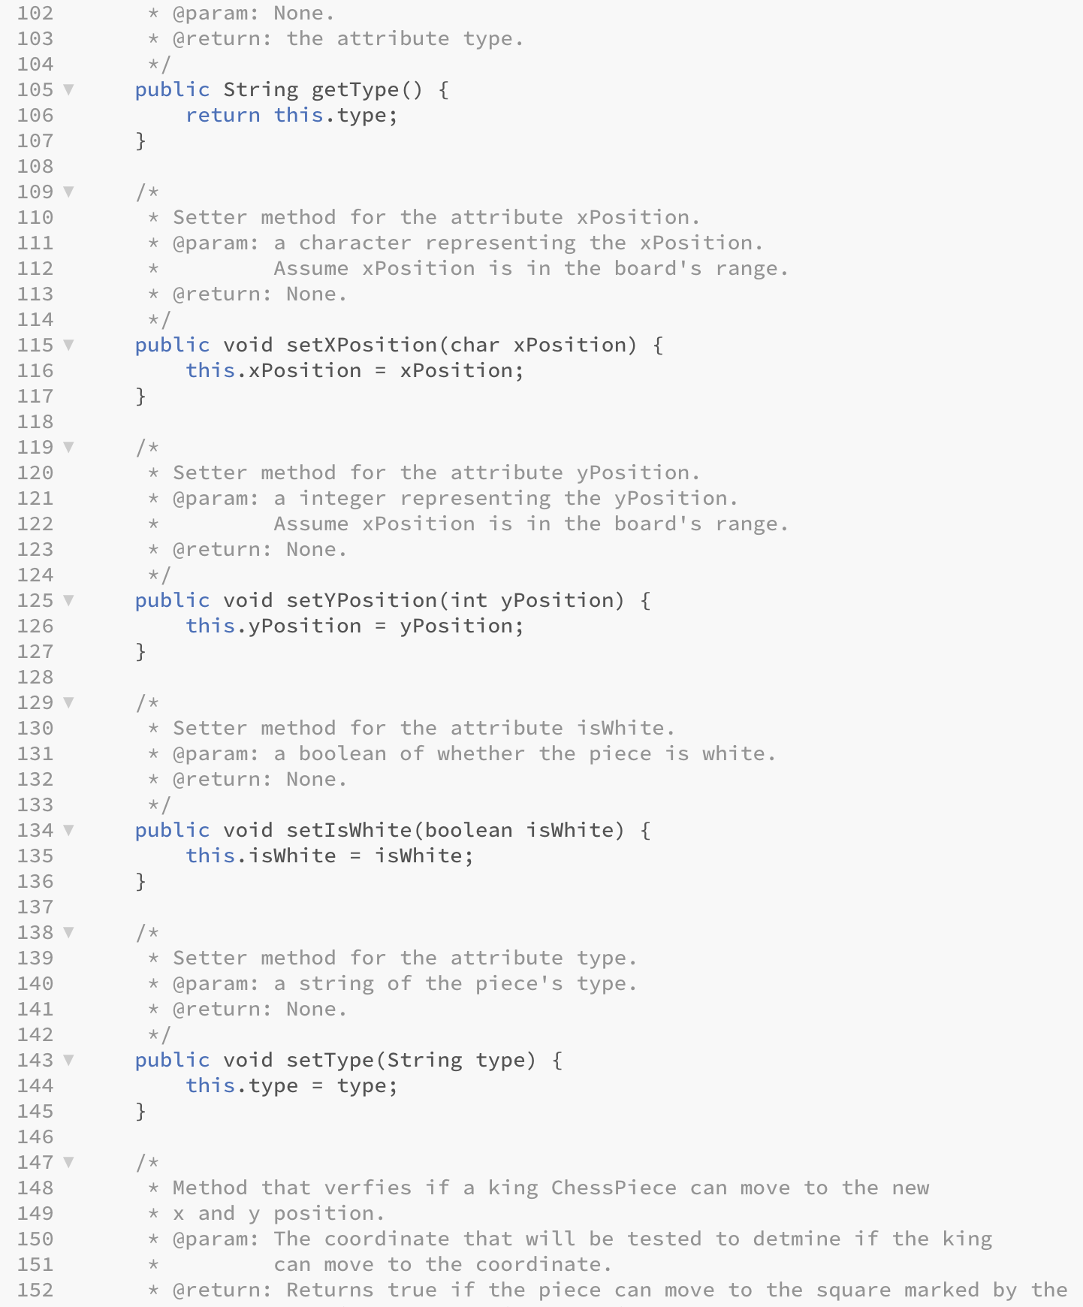

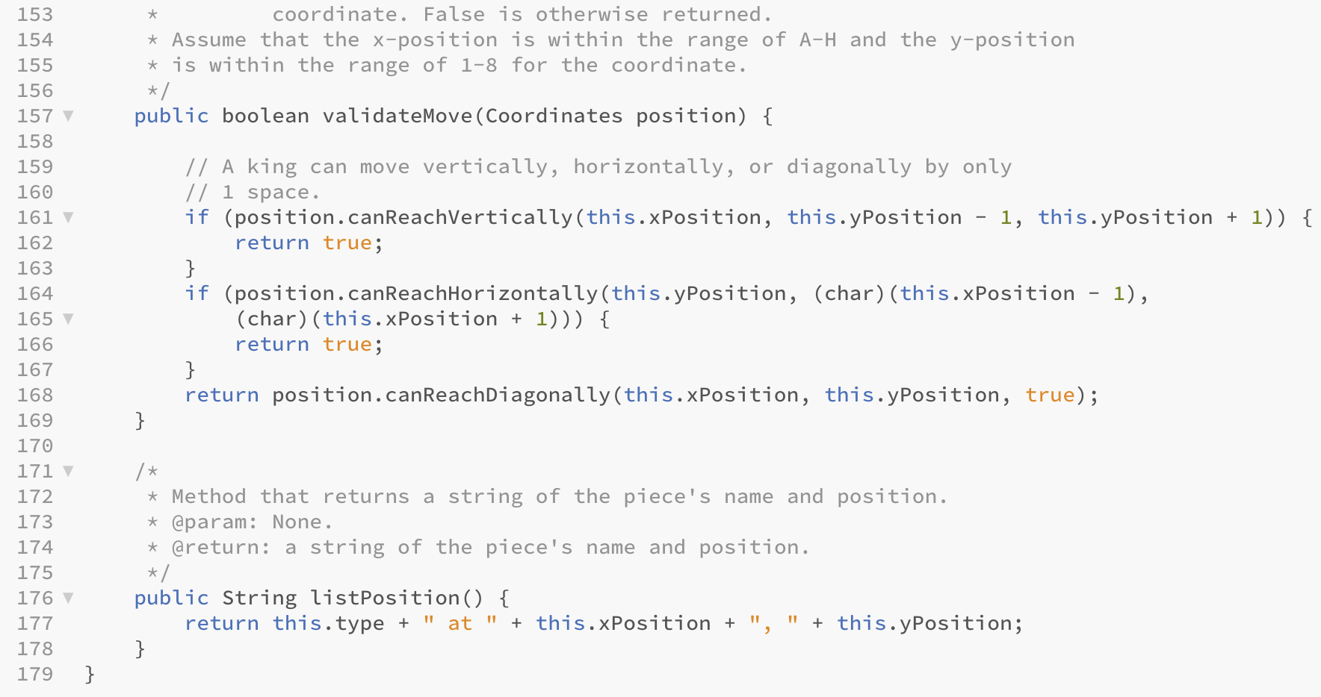

Coordinates.java

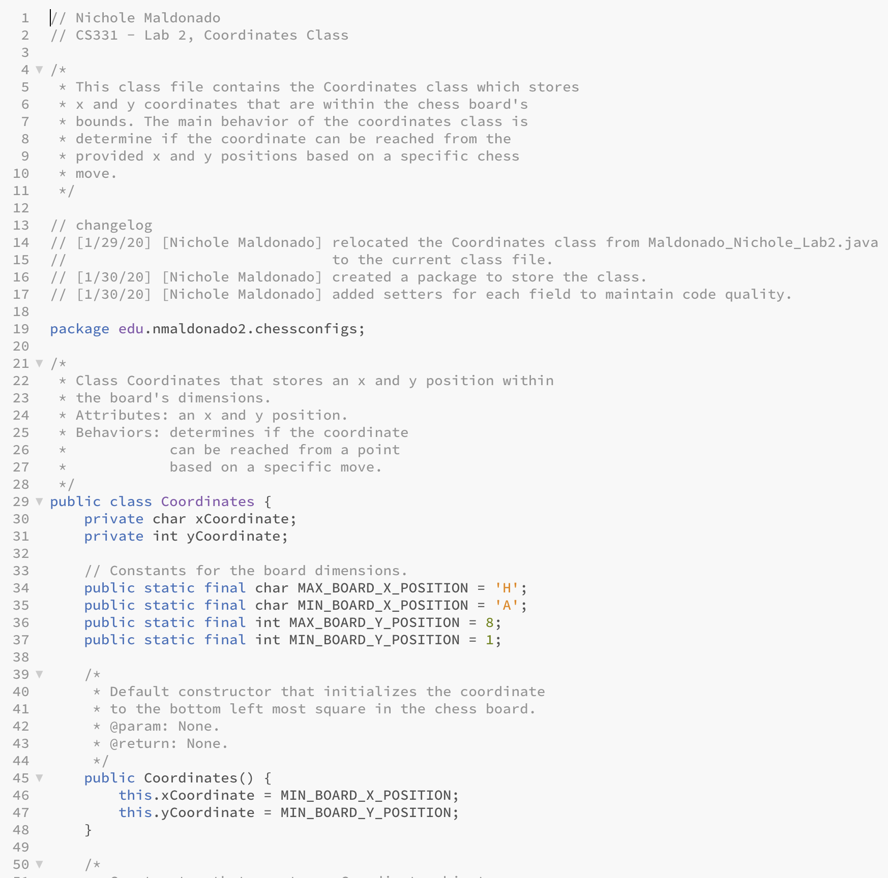

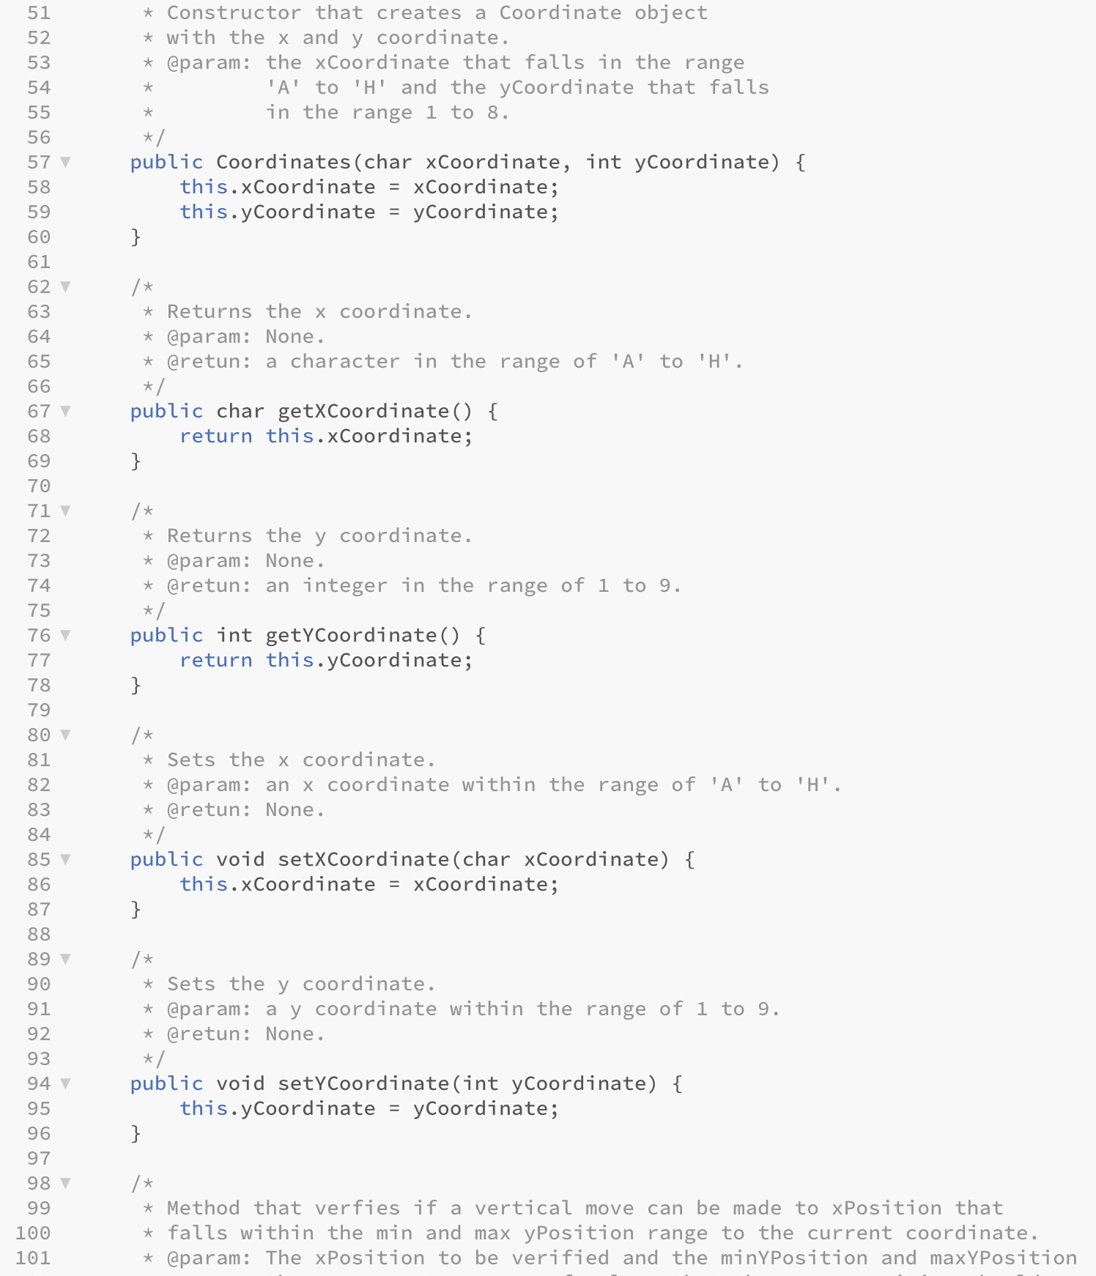

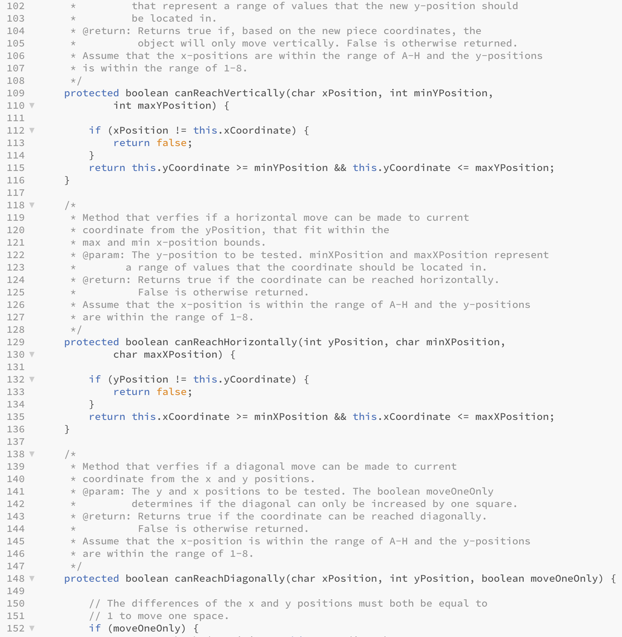

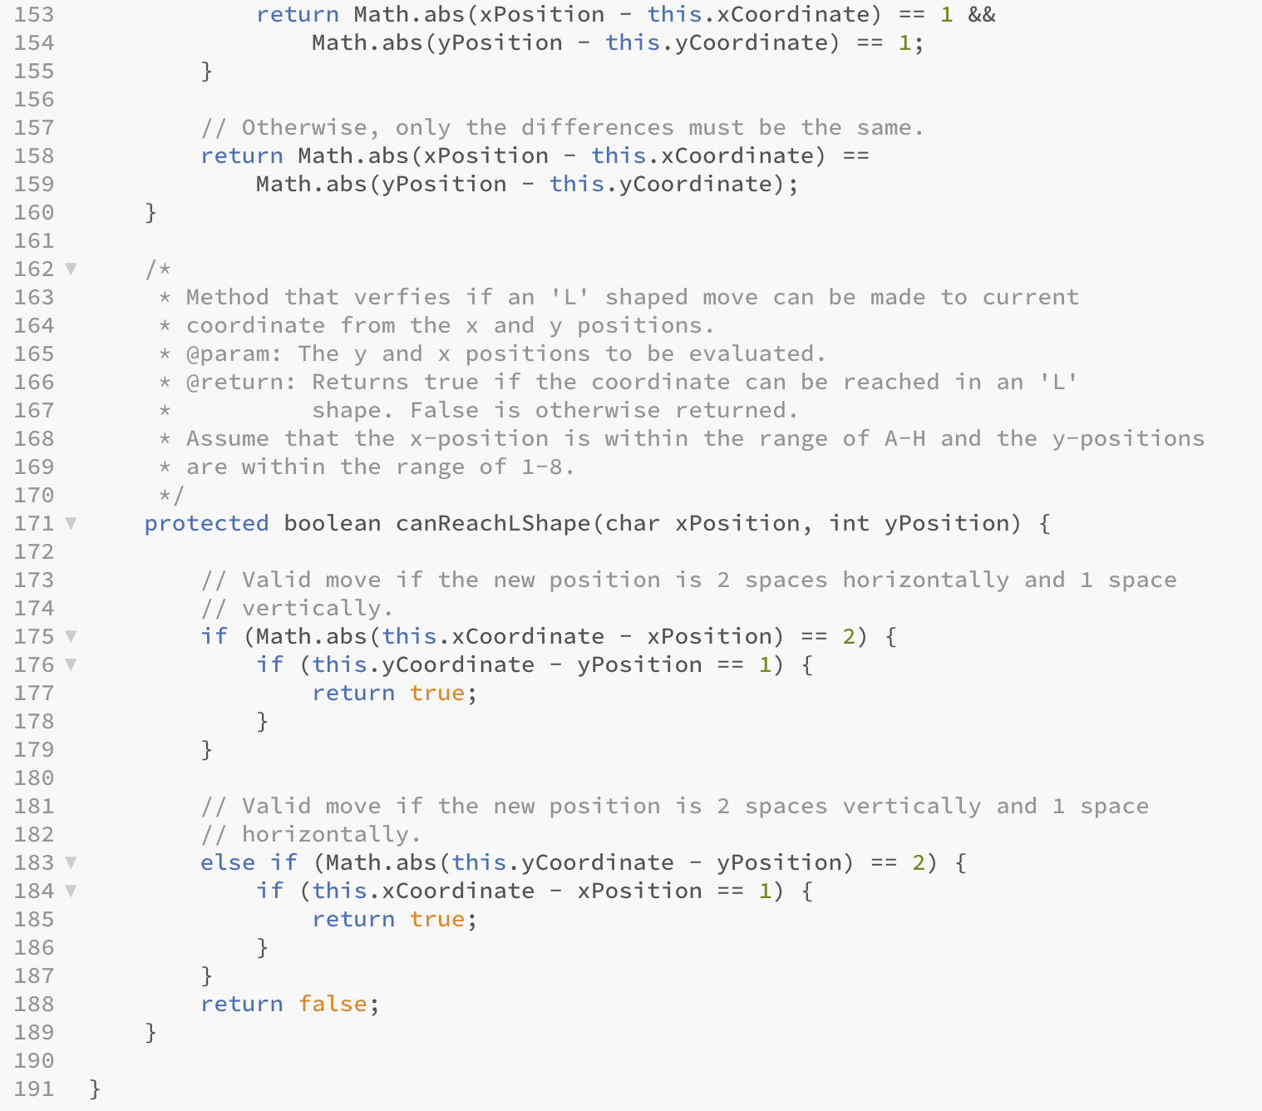

ChessPieceTypes.java

